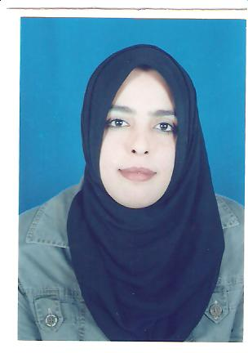

**Centre for Intercultural Research in Communication & Learning (CIRCL)**

**Suhyla Elarbash: Research Student**

Suhyla Elarbash holds **BA in English Language** from Zwara University-Libya and an **MA in Applied Linguistics** from University of 7th of April- Libya and also holds an MA in **English Language Teaching** from De Montfort University.

After completing her MA, Suhyla Elarabsh is currently a full-time PhD student in the Centrefor Intercultural Research in Communication & Learning (CIRCL), sponsored by Libyan government. Her research focuses on the importance of integrating and teaching of the target cultures into English as a Foreign Language (EFL) textbooks and classrooms. This is important for the English language teaching and learning in Libya, because her initial investigation shows that most English textbooks used in Libyan schools completely ignore the teaching of the target cultures.

**Other Interests**: Travelling, music and teaching.