

Making a Change: A guide to running successful and accessible workshops and training

2008

Written by Michael Glynn, Catherine Bewley, Fran Branfield, Michael Turner and Peter Beresford, Jabeer Butt, Suzy Croft, Kiran Dattani Pitt, Jennie Fleming, Ronny Flynn, Charles Patmore, Karen Postle.
Contents

- Acknowledgements

- Summary

- Introduction
- Introduction
- Background to the Standards We Expect Project

- Developing a Programme
1) The need for training
2 )Aims and objectives
3) The trainers
4) Paying the trainers
5) Working out a programme for the training

- Access and Arrangements
6) Time
7) Telling people about the training
8) Finding out what people need to take part
9) Where to hold the training
10) Equipment
11) Food and drinks
12) Introductions
13) Handouts
14) Language
15) Ground rules and supporters
16) Travel
17) What the trainer needs to take part
18) Help after the training
19) Being flexible

- Evaluation and monitoring
20) Finding out what people think about the training
Results of evaluation
Trainers’ feedback forms

- Practitioners and managers

- Conclusions

- Appendices
- Summary of Top Tips & Checklists
- Brief Facts About the ‘Making A Change’ Programme
- Training Brief for Trainers
- Invitation to Trainer’s Meeting
- Programme of Trainer’s Meeting
- Contract Letter for Trainers
- Example of Workshop Programme
- Flyer for Making a Change Workshop
- Access Checklist
- Access Form for Project’s Second Get Together
- Suggested Ground Rules for Meetings
- Shaping Our Lives Protocol for Personal Assistants
- Adult Protection Guidance for Trainers
- Equal Opportunities Monitoring Form
- Evaluation Form
- Follow-up Evaluation Questions

Acknowledgements

We would like to thank all the service users who came to our workshops. You helped us find out what we did well, and what we could have done better!

Thank you to all the trainers who took part in the workshops.

Thanks to all our colleagues at the services who took part in our project. Thank you for your help in setting up the workshops.

Summary

This is a summary of ‘Making a Change: a guide to running successful and accessible workshops and training’. It shows the most important parts of the guide in a short, clear way.

Our project set up training for a lot of service users. We wanted everyone to be able to take part. We looked for a guide telling us how to plan the training. We could not find one. So we decided to write our own guide.

The summary is a quick and easy way to use the guide when you are planning training. You can find out more by reading the full guide.

Each part has a ‘Checklist’. This has questions we think you should ask when you are planning training

1) The Need for Training


TOP TIP: The idea for training can come from different places. It is important to be clear what the need for training is.

You might want to check that people can’t get the same training somewhere else before you start planning it.

CHECKLIST: THE NEED FOR TRAINING

- What is the need for training?
- How did you find out about the need for training?
- Did service users have a say in what training was needed?
- Who is the training for?
- Does anyone else already do this training?
- Who will pay for the training?
- Will you charge people for coming to the training? Or for food and drinks?

2) Aims & objectives (what we want to get from the training)

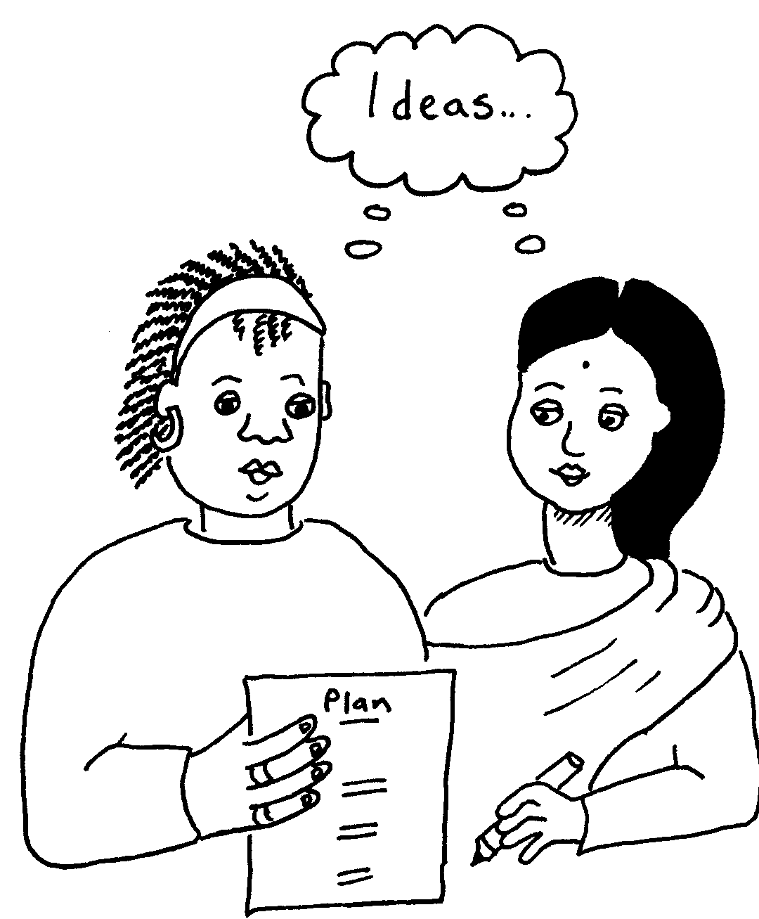
TOP TIP: It is important to be very clear about what you want to get from the training.

It can help to think about the training as a journey. Your aims tell you where you want to get to on your journey. Your objectives tell you how you will get there – they are the different stages of your journey.

You should write this down in a plan. If they are not clear the training probably won’t work very well.

CHECKLIST: AIMS AND OBJECTIVES

- Are you clear about what you want to get from the training?
- Are your aims and objectives clear? Will you be able to reach them?
- Have you written a plan? Does it say what you want service users to learn at each bit of the training?
- How will each training session teach service users what you want them to learn?

3) The Trainers

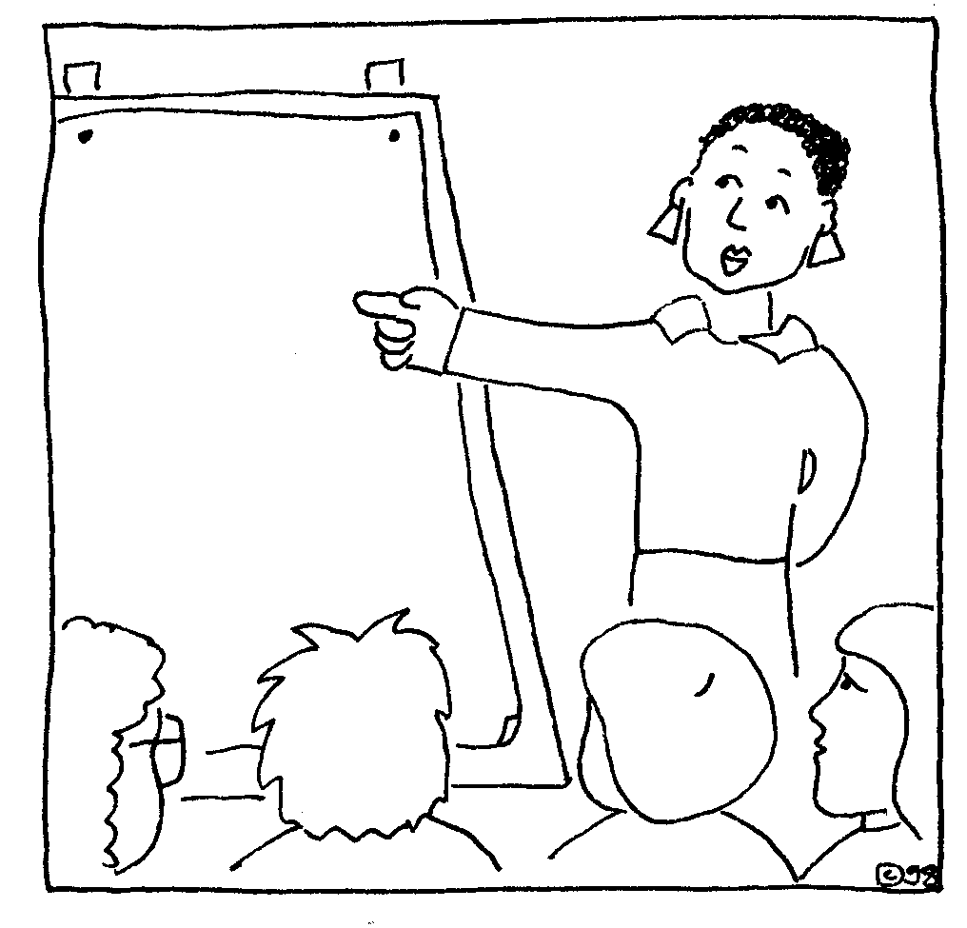
TOP TIP: You should think about who is the best person to give the training. You will need skilful trainers who know about the subject. Experience and background knowledge are important.

You can ask what the service users think about the trainer. For example, service users might feel happier with a trainer who is a service user.

CHECKLIST: THE TRAINERS

- How many service users do you want to come to the training?
- How many trainers do you need for each bit of the training?
- What skills and experience do you want trainers to have?
- Do trainers for different bits of the training need different skills or experience?
- Would it be good to have trainers who have used services?
- Would it be good to have trainers who know a lot about the background to the training, for example about the social model of disability?
- Would it be good to have trainers who know about other cultures for the training?
- How can you find trainers with the experience you want?

4) Paying the trainers



TOP TIP: Trainers should be paid the right amount of money for the work they do. Their skills and experience is important. This is part of what it costs to set up the training.

CHECKLIST: PAYING THE TRAINERS

- What is the right amount of money to pay the trainer?
- Can you find out what other trainers are paid?
- Could trainers who are service users lose welfare benefits or have money problems because they take part?
- Where can service users find out more about how payments might effect their benefits?
- Will you have a written contract with the trainer(s) for the training?

5) Working out a programme for the training

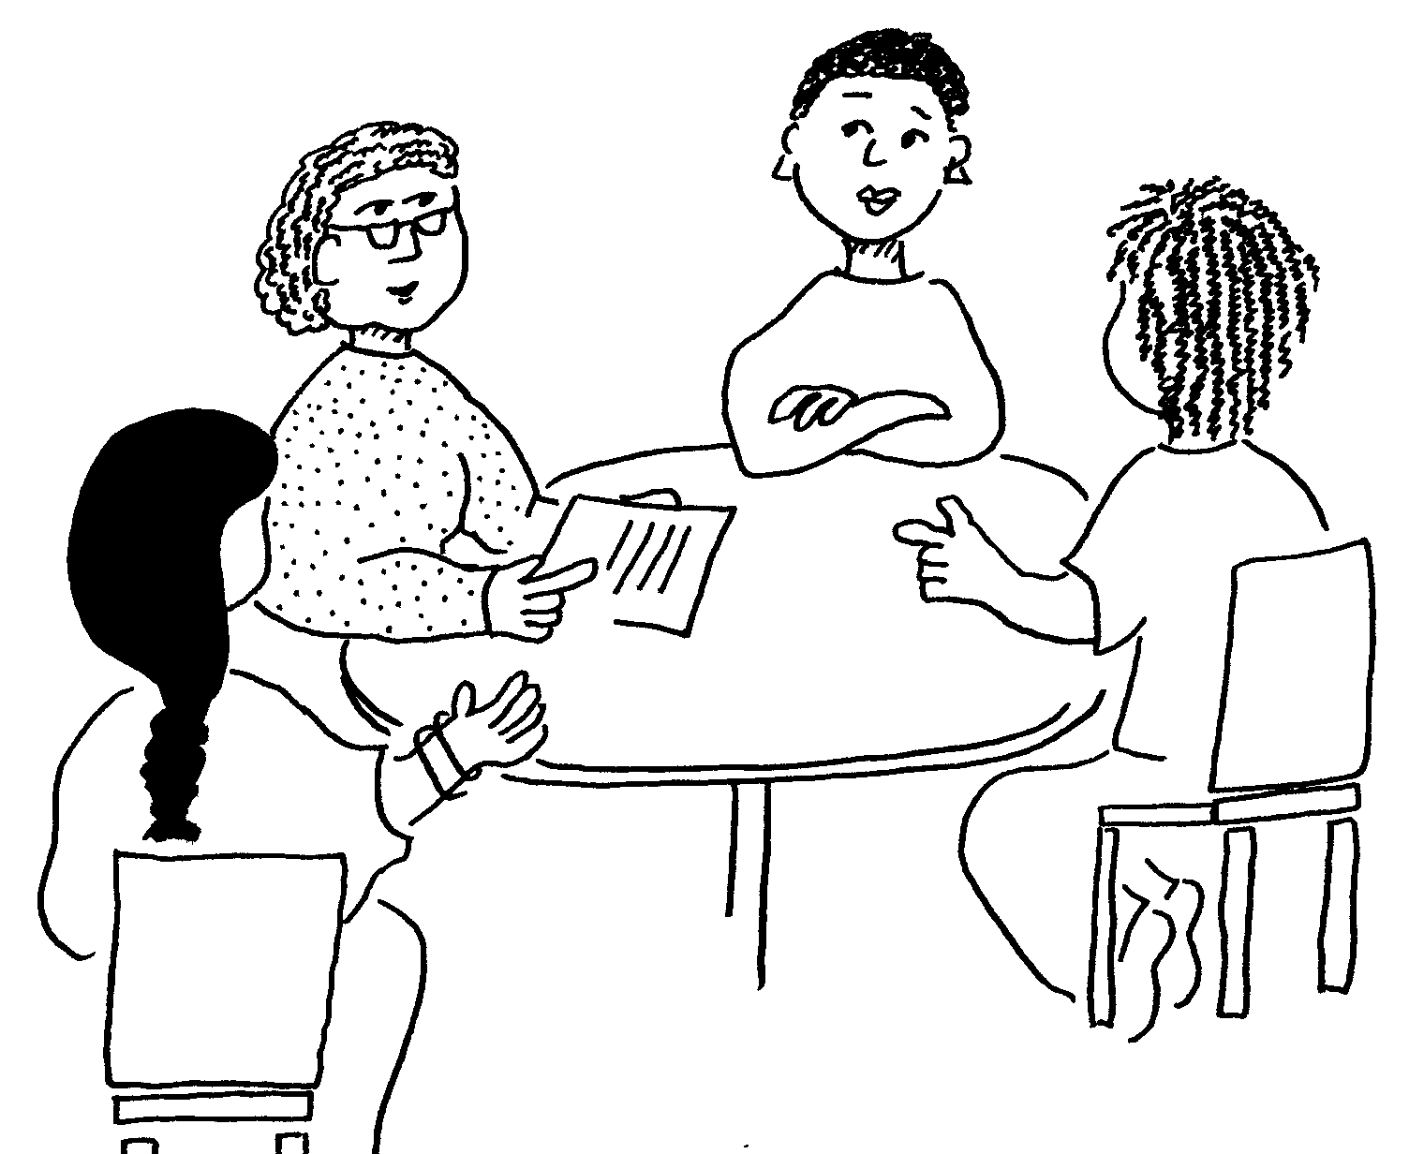
TOP TIP: You will need a programme for each bit of training. A programme shows what a trainer will do, and when.

You should find out what help your trainer needs with this. If there are lots of trainers you could hold a meeting with them.

CHECKLIST: WORKING OUT A PROGRAMME FOR THE TRAINING

- Are there different trainers giving the training? Would it be good to meet together to talk about the programmes?
- What do you want to get from having a meeting?
- How will you record what is said at the meeting?
- Do you have money to pay the trainers to come to the meeting? Who would pay for the trainers’ travel to the meeting and their expenses?
- Do the trainers need any background information? How will you make sure the trainers have the background information they need?
- Will you have one-to-one meetings with the trainers to plan their programmes?
- Do trainers need any information about the service users taking part or what they need to take part?

6) Time


TOP TIP: When you write the programme for the training you should think about what service users need to take part.

You should think about the amount of time needed. You should make sure there are regular breaks. You might need more than one day to make sure service users learn everything.

CHECKLIST: TIME

- How long do you need to do the training? How many hours or days do you need?
- Do you need more time so that everyone can take part?
- What time should a training day start? What time should it end?
- How many breaks should there be? How long should the breaks be?
- When should the training be? Are there times of the year, or days of the week that service users can’t come to training?
- Can you change when the training is to suit service users?
- Would service users rather have training close together or spaced out over a longer time?

7) Telling People about the Training


TOP TIP: You should think about who the training is for. You should think about the best way of telling people about the training.

You might tell them at a meeting. You might send an invitation in the post.

CHECKLIST: TELLING PEOPLE ABOUT THE TRAINING

- Who is the training for?
- How will you tell service users about the training?
- Will you send out invitations in the post?
- Would a leaflet or poster help?
- Can you go to a meeting to tell people about the training?
- Who can help to tell people about the training?
- Are there local groups of service users who can help tell people about the training?
- Can you use a number of different ways of telling people about the training?
- How will you make it clear to service users what the training is for?

8) Finding out what people need to take part


TOP TIP: You need to find out what service users need to take part in the training. You can find this out by sending people a form to fill in. Or you can speak with each person who is coming to the training.

CHECKLIST: FINDING OUT WHAT PEOPLE NEED TO TAKE PART

- How will you find out what each service user needs to take part in the training?
- How will you find out everything you need to know?
- How will you make sure you don’t miss anyone out?
- Will you be able to help everyone to take part in the training?
- Have you thought about how to help everyone to take part (for example, how to get an interpreter, or what foods someone with a gluten-free diet needs)?
- Will it be useful to send a form or checklist to the service users who are coming to the training?
- Will everyone be able to fill a form in?
- Can you use other ways of finding out what people need to take part?
- What will you do if service users do not send back their forms?
- Will it be useful to speak with each service user to find out what they need to take part?

9) Where to Hold the Training


TOP TIP: You should think about the best place to hold the training. Where do people coming to the training live? How easy is it to get to. You should think about places that make it easy for people to take part.

CHECKLIST: WHERE TO HOLD THE TRAINING

- Where is the best place to have the training?
- How far will service users have to travel? How long will it take them?
- Does the place have level access for wheelchair users?
- Does it have toilets that are accessible? If you are holding a session for a lot of service users you may want to find out how many accessible toilets there are.
- Does it have chairs and tables that people can use easily?
- Are there different types of chairs? For example some people may need a chair with a high back.
- Are the rooms the right size for your training? Are there enough rooms?
- Is there enough space in the rooms you are using?
- Sometimes you might need to take some chairs or tables out of a room to make space. Will people at the place do this for you?
- If you are using more than one room are the rooms next to each other? Is the distance between rooms a problem for service users? Or will moving between rooms take a long time?
- Are the rooms quiet enough? Can other people in the building hear what you are saying?
- Will other people using the place disturb your training?
- Does the room have good, natural light?
- Is the room nice? Will people be happy using it for the training?
- Does the room have an induction loop for people with hearing impairments? Or is there a portable loop system that can be used?
- Is there a prayer room or quiet room for people to pray in?
- Is there a quiet room for people who need a break from the training?
- Is the place easy to find? Is there a map you can send to people who are coming to the training?
- Is it easy for people to find their way around the building? Are there signs? How can you help people to find their way around?
- Does the place have a website that service users can visit to find out more?
- Is there enough parking? How far away is the parking? Is it free? Can it be used at the time of your training?
- Can you save parking spaces for service users who need it?
- Is there an open space where people with assistance dogs can go during breaks?
- Is there a kitchen?
- How much does the place cost?
- How do you book a room? Do you have to pay some money up front before you use the room (a deposit), or sign a contract?

10) Equipment


TOP TIP: You should find out what equipment is needed at the training session. For example does the trainer need a flip-chart or a lap-top computer? Before the training you will need to arrange the equipment.

CHECKLIST: EQUIPMENT

- Do you know what equipment the trainer needs?
- Do you own the equipment you need? How will you get it to the training?
- Can the trainer bring the equipment they need?
- Can the place you are having the training lend you the equipment you need?
- Can you borrow or hire the equipment you need?
- Can the equipment be taken to the venue (and picked up) at the right time?
- What is the cost of hiring the equipment?
- If the equipment costs a lot or is hard to find can the trainer(s) change their plan and do without it?

11) Food and drinks


TOP TIP: If you have food at the training you need to plan who will cook it. You should make sure you have food the people at the training can eat. For example you might need vegan or nut-free food.

The place where you have the training might do food. Or you might need to arrange caterers to bring lunch. You should also make sure there are drinks.

CHECKLIST: FOOD AND DRINKS

- Will you have lunch at your training? This might depend on how long the training is and what time of day it is.
- Can the place where you have the training do lunch? If they do they might not let you have other caterers.
- If there is a restaurant there do you want to use it? How long does it take to serve lunch? Will all the service users be able to use the restaurant?
- Can you have lunch in your training room?
- Is the food OK for vegetarians or vegans? Is it nut-free or gluten free?
- Is the food labelled clearly? For example can people tell which food is vegetarian? Is it on different plates?
- Can you get drinks at the place you have the training?
- Are there drinks for people who don’t have caffeine?
- Are there drinking straws for people who need them?
- Is there a kitchen you can use to make drinks?
- Are there cups or mugs you can use?
- Do you need to bring coffee, tea, milk and sugar? Who will make the drinks?

12) Introductions

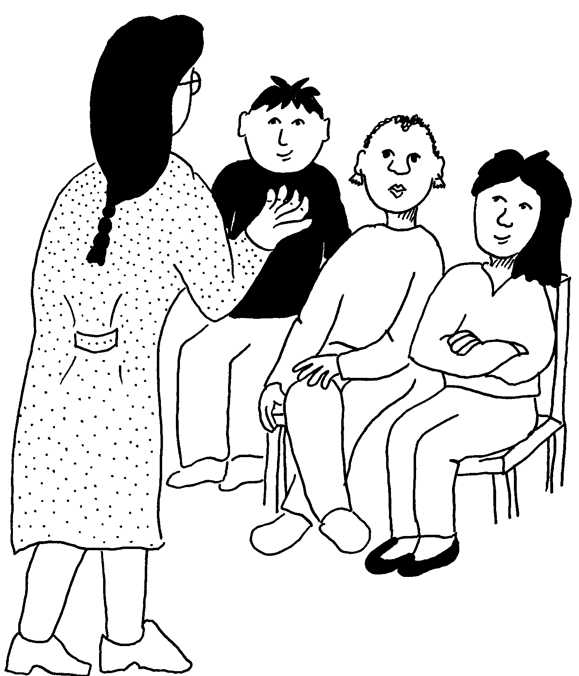
TOP TIP: Each training session should start with an introduction. You should talk about the background of the training. You should tell people what the training is for.

You might ask the trainer to do the introduction. You might want to do the introduction yourself.

CHECKLIST: INTRODUCTIONS

- Who will tell people who the trainer is?
- Who will talk about the background of the training?
- Who will tell people what the training is for?
- Is the trainer happy to do the introduction?
- What background is needed in the introduction?
- What will you tell people about what the training is for?

13) Handouts


TOP TIP: Remember that not everyone will be able to use handouts. For example people who can’t see very well or people who can’t read. You should talk about this with your trainer. Are there other ways of doing the training that don’t need handouts?

CHECKLIST: HANDOUTS

- Do you need handouts at the training?
- How can handouts be changed so more people can use them?
- Will you make large print handouts (or have them on tape or in braille)?
- Do your handouts use plain language and symbols?
- Will the trainer read out the information on a handout and talk about it?
- Can you send handouts to service users before the training? This might help people get ready, or get help to read them.

14) Language


TOP TIP: It is important to find out if people coming to the training understand enough spoken and written English to take part equally.

You might need an interpreter for some service users. An interpreter changes what someone else says into another language. The interpreter could be for deaf people who use British Sign Language.

CHECKLIST: LANGUAGE

- Will there be anyone at the training who doesn’t speak enough English to take part equally? How will you help them to take part?
- Will any of the service users have speech impairments or limited verbal communication? How will you help them to take part?
- Will anyone need an interpreter?
- Do you know how to arrange for an interpreter?
- What will the costs for an interpreter be?

15) Ground Rules and Supporters


TOP TIP: It is important that people get on well at the training. It is important that service users can say the things they want to say. To help with this you can ask everyone to agree to some ground rules. You can tell people what you expect from supporters and personal assistants at the training.

CHECKLIST: GROUND RULES AND SUPPORTERS

- Will you ask people to agree ground rules for the training?
- Do you have other ideas to help people get on well at the training?
- Do any service users need a supporter or personal assistant with them at the training?
- How can you make sure that service users have their say, not supporters or personal assistants?
- Will you ask supporters and personal assistants not to talk unless they are helping a service user talk?

16) Travel


TOP TIP: Travel can be difficult for service users. It can take a long time to get to the training. Some people need help to travel. Some people need help to find out how to get there. You should find out if service users can use public transport to get to the training.

CHECKLIST: TRAVEL

- How will service users get to the training?
- Do you have enough money to pay for service users’ travel?
- Do service users need help to travel? Who will help?
- Do you need to change the start and finish times because it takes a long time to travel to the training and back?
- Can you help service users find out how to get to the training?
- Can you help arrange travel for service users?

17) What the trainer needs to take part


TOP TIP: Trainers who are service users may need help to do the training. You should ask the trainer what they need to take part. You should help arrange the help they need. They might need help with travel and where they stay as well as at the training.

CHECKLIST: WHAT THE TRAINER NEEDS TO TAKE PART

- What help does the trainer need to take part?
- Is the place for the training accessible for the trainer?
- What agreement will you have with the trainer about paying and arranging for support, travel and a place to stay?
- Does the trainer need a support worker?
- Does the trainer need help with travel plans?
- Does the trainer need help planning or booking a place to stay?

18) Help after the training


TOP TIP: Training makes people think about new ideas or choices. This can be difficult or upsetting for some service users. It might be difficult for people who don’t have much support. It might be difficult for people who live in residential homes.

You should think about what help people might need after the training. You should think about who can give this help.

CHECKLIST: HELP AFTER THE TRAINING

- Will the training upset any service users?
- How can the training be helpful and make everyone feel supported?
- How can you help service users after the training?
- Are there local groups who can help service users after the training?
- How will service users get in touch with groups who can help?

19) Being Flexible

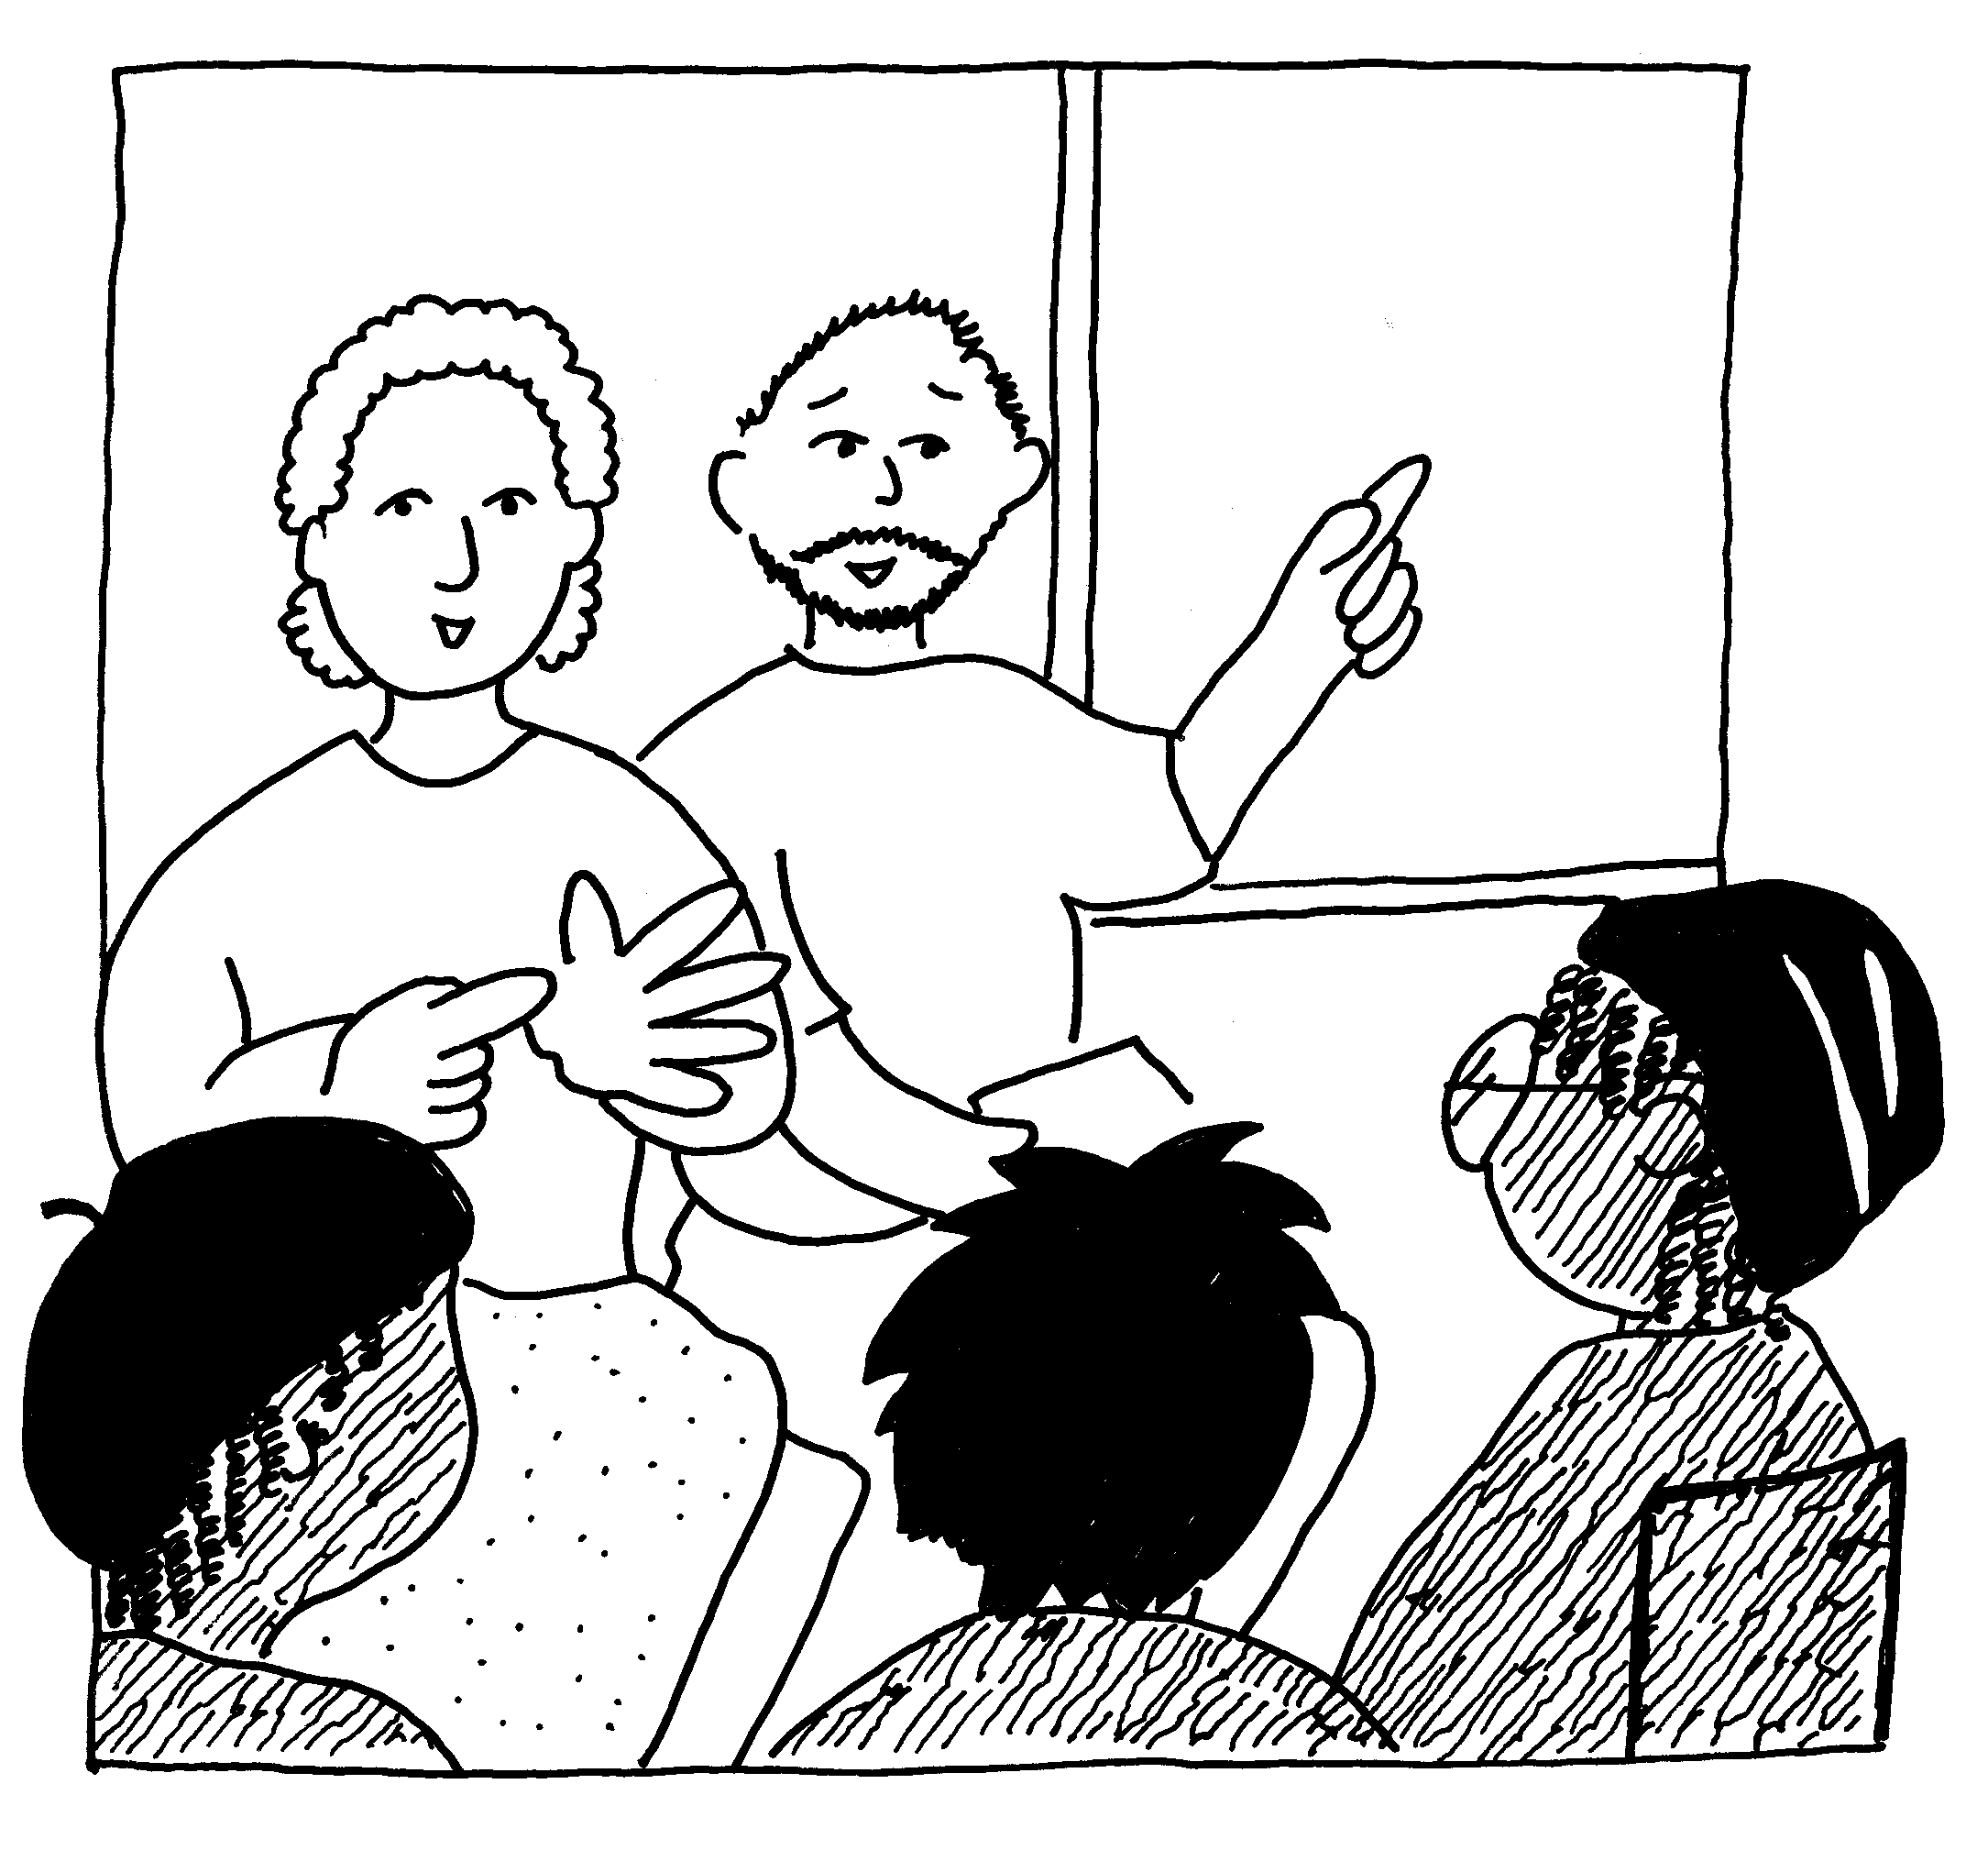
TOP TIP: One of the most important things about planning training that everyone can use is being flexible. You have to be able to change things to help people take part. This guide tells you how to do training that everyone can take part in. But it can’t tell you everything.

Different people need different things to help them take part. Some people will need unusual things. You might have to make last minute changes.

CHECKLIST: BEING FLEXIBLE

- How will you help if service users need unusual things to help them take part?
- How will you make sure you work in a person-centred way?
- Do you have enough time to make sure you can help everyone to take part?

20) Finding out what people think about the training
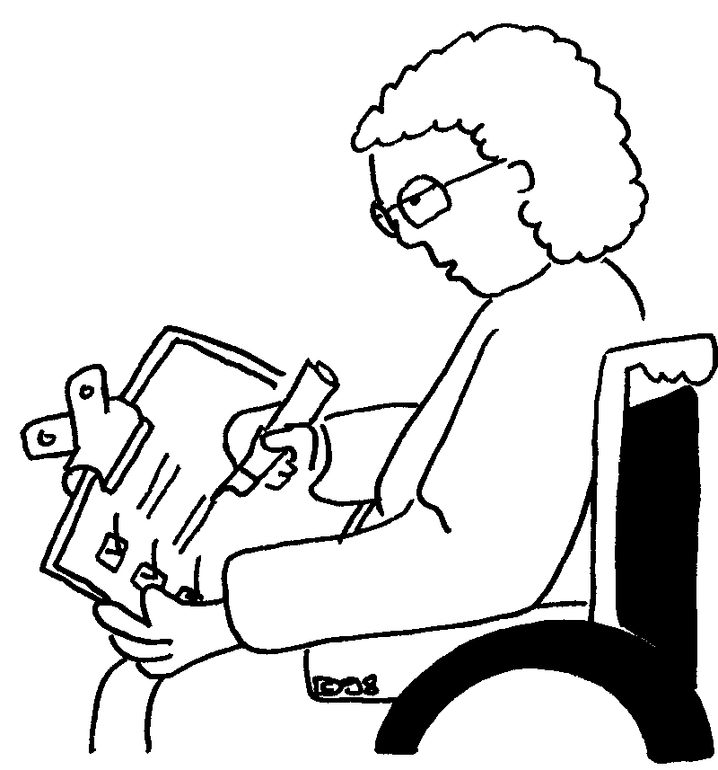

TOP TIP: It is important to find out what people think about your training. What people say helps you find out if your training worked. It helps you find out what things went well and what things you could do better. People might tell you how to make it better.

CHECKLIST: FINDING OUT WHAT PEOPLE THINK ABOUT THE TRAINING

- Do you want to find out things like age, sex and ethnic background?
- What sort of things do you want to find out about the training?
- What is the best way to find this out?
- Do you want people to fill in a form?
- Do you want to get in touch with people afterwards and ask them questions?
- What questions will you ask?
- How many questions will you ask?
- What can you make sure everyone can have their say?
- How will you get lots of people to answer the questions?
- Will you ‘follow-up’ later to ask more questions about your training? For example you could talk to people a month after the training. You could ask if the training has made a difference to them.
Introduction


This guide is based on the evaluation of a programme of workshops that were part of the Standards We Expect Project in 2007. The workshops were aimed at a wide range of service users taking part in the project. We wanted everyone to be able to take part equally. We called them ‘Making a Change’.

We learnt a lot from developing the programme. The workshops went very well but we found it was difficult to set them up. We looked for a guide about arranging accessible training but found nothing useful. So we decided to write a guide based on what we found out. It is based on the wider experience of the people and organisations that are part of our project. Many of them are service users.

Our programme of workshops included sessions for practitioners and managers. But this guide is mainly about the programme we set up for service users. We hope it will be useful to people arranging training for the first time or for experienced trainers who want to include people equally in their sessions.


The guide includes all the stages of setting up a training programme. It starts with deciding on what training is needed and goes all the way through to evaluation. It gives general advice and examples of what we did in the Standards We Expect training programme. A lot of the book is about how to include everyone in the training and how to make sure everyone has a say and can take part equally.

At the beginning of each part you will find a ‘Top Tip’ which is the most important advice from that section. You will find a checklist of questions to think about at the end of each part. The Top Tips and checklists have been put together in the Summary.

The guide includes lots of advice about making practical arrangements. This includes picking a trainer for the programme and picking where to hold the training. It includes the results of our project’s evaluation of its programme to show what service users said were the most important things about training.

At the end of the guide we have included lots of documents we used throughout the programme. These include our original programme brief for trainers and things like our access checklist and evaluation forms. We hope these will be useful for you. You can use them, or adapt them for your training.

A brief word about money…

The Standards We Expect Project was funded by the Joseph Rowntree Foundation. We had a budget that was large enough for us to make sure that our training was fully accessible. An important part of planning training is thinking about the money you will need and where to get it. You should plan so that you have enough money to make the training accessible to everyone who comes to it. This may mean thinking about money at an early stage, for example when you are writing your funding bid.

Background to the Standards We Expect Project

The Standards We Expect Project was a research and development project funded by the Joseph Rowntree Foundation. It guided the development of person-centred support in 8 services across the UK. It worked closely with service users and practitioners because they have often not been included in social care research.
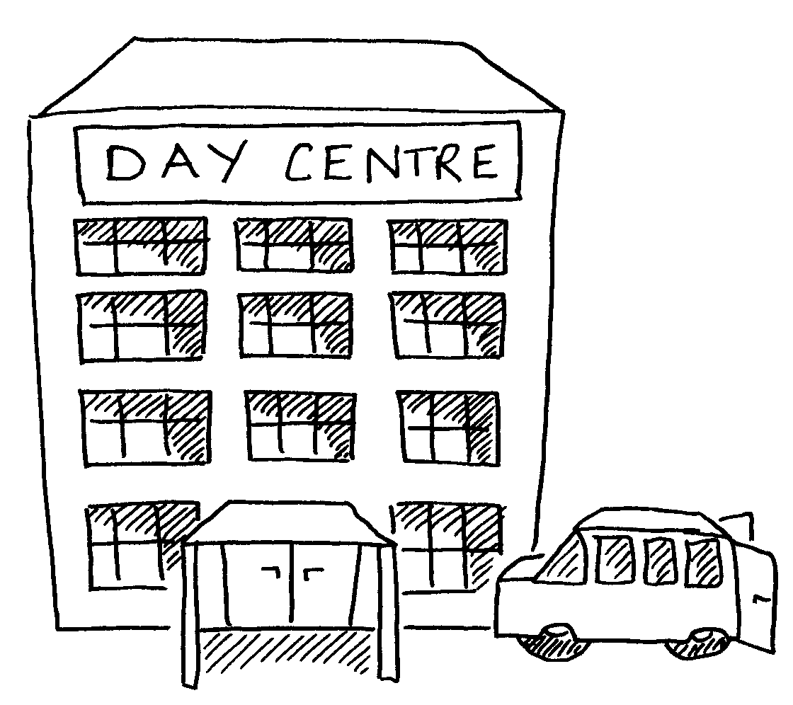
The services ranged from residential homes to day centres and out-reach services. They worked with different age groups, from young adults to older people. Some people using the services had learning difficulties, others had physical impairments or dementia.

Much of the development work was done individually with the services. There were some types of support, such as national meetings and training that we offered to all 8 services.

A Get Together event was held by the project in November 2006. It was the first chance for people from the services to meet together. It gave service users, practitioners and managers the chance to talk about

  - What person-centred support means
  - What the barriers are to person-centred support
  - How to overcome the barriers to person-centred support

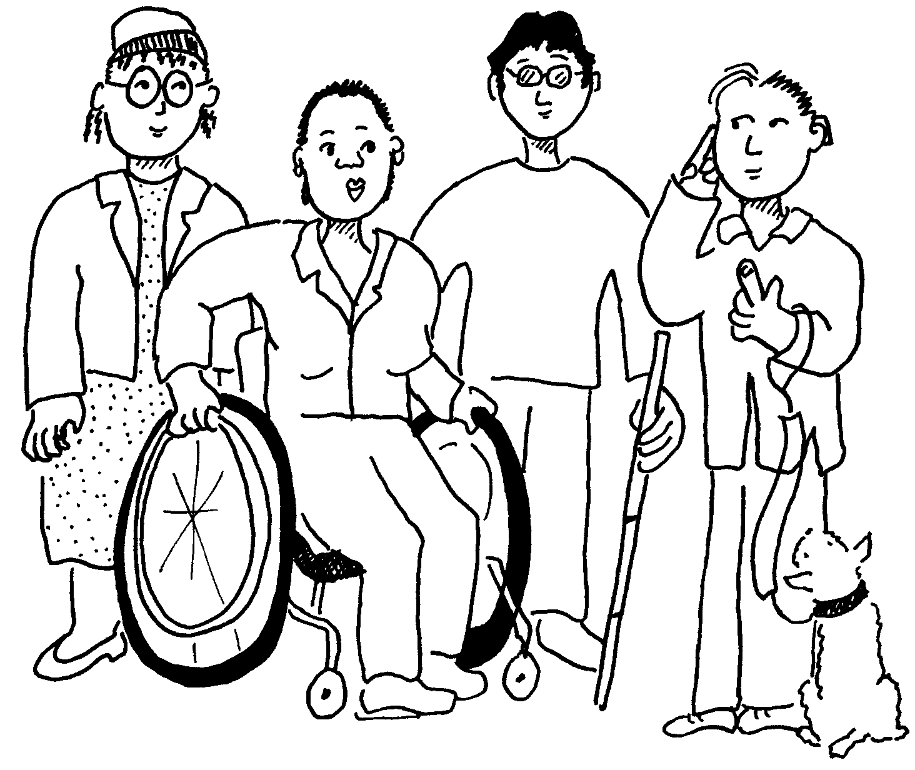
Along with individual work with the services this event helped us to find out how we could support services to develop. People at the event were very clear that the best ways to overcome the barriers to person-centred support are

- Training about person-centred support, rights and making choices
- Accessible and up to date information about what services are available
- Service users being involved in how services develop
- Supporting service users to build confidence

Developing a Programme

1) The Need for Training

TOP TIP: The idea for training can come from different places. It is important to be clear what the need for training is.

You might want to check that people can’t get the same training somewhere else before you start planning it.

An original idea for a training session, or programme of training, can come from a variety of different sources. You may be contacted by a group of people who want some training. You may meet some people who need some training as part of other work you are doing. You may be approached by a third party, like a Community Worker who has identified a training need. However the idea comes about it is important to be clear what the need is and who the training is for. It is a good idea to try to find out if similar training is already available before you begin planning.

Following its first project Get Together, the Standards We Expect project decided that a programme of training could help service users to find out information as well as learn more about involvement. It was hoped it could assist service users to develop more confidence.

It agreed aims and objectives for the workshops but decided it wanted individual trainers to develop the detailed programmes for workshops. This reflected both the diversity of the groups involved and the skills and experience of the trainers.

The project offered workshops to groups of service users who were part of its project partner sites on a local basis. To reflect the particular needs of a service for people from a minority ethnic community the project also provided workshops for the family carers of their service users.

The project had a sufficient budget to offer the training to service users for free. There were no charges for attending and refreshments were also free.

CHECKLIST: THE NEED FOR TRAINING

- What is the need for training?
- How did you find out about the need for training?
- Did service users have a say in what training was needed?
- Who is the training for?
- Does anyone else already do this training?
- Who will pay for the training?
- Will you charge people for coming to the training? Or for food and drinks?

2) Aims & objectives

TOP TIP: It is important to be very clear about what you want to get from the training.

It can help to think about the training as a journey. Your aims tell you where you want to get to on your journey. Your objectives tell you how you will get there – they are the different stages of your journey.

You should write this down in a plan. If they are not clear the training probably won’t work very well.

The Standards We Expect project developed the following aims and objectives for our workshops:

- The overall aim of the programme of workshops was to enable service users to take part more equally in discussions about person-centred support and possibly be a catalyst for change in sites.

Aims:

By the end of the training service users will:
- Have a better understanding of their rights as disabled people/service users
- Have more knowledge, confidence and control over their life
- Have a better understanding behind Independent Living and person-centred support and the barriers to achieving it.

Objectives:

By the end of the training service users will:
- Know about the social model or equalities approach towards disabled people/service users
- Know more about person-centred support
- Have discussed what these things mean for themselves and their service
- Have discussed what changes they might want in their lives and the service they receive
- Have met other service users in their services/area
- Know more about the Standards We Expect project.

(The full brief drawn up for trainers is in appendix 2)

CHECKLIST: AIMS AND OBJECTIVES

- Are you clear about what you want to get from the training?
- Are your aims and objectives clear? Will you be able to reach them?
- Have you written a plan? Does it say what you want service users to learn at each bit of the training?
- How will each training session teach service users what you want them to learn?

3) The Trainers

TOP TIP: You should think about who is the best person to give the training. You will need skilful trainers who know about the subject. Experience and background knowledge are important.

You can ask what the service users think about the trainer. For example, service users might feel happier with a trainer who is a service user.

The trainers for the Standards We Expect programme were chosen for their

- Experience as trainers
- Relevant personal experience as service users and practitioners
- Experience in working with service users
- Commitment to the principles of independent living and the social model of disability
- Ability to travel (with support as necessary) to the relevant UK location to deliver the training

For the majority of the workshops the project employed 2 trainers per workshop. This was to enable facilitated small group work, to enable different perspectives and assist different participants to feel comfortable. It also enabled a mixture of ideas and approaches at the session planning stage. The sub-group felt that groups should have limited numbers in order that trainers could work closely with participants.

The project made great efforts to find trainers whose own experience and knowledge would best suit the individual groups of service users we were working with. This was done by using the consortium group’s extensive contacts within the field of training. It must be emphasised that trainers were primarily chosen for their capabilities and experience as trainers.

- Trainers with a learning difficulty worked with groups of service users with learning difficulties. They were supported as necessary by a facilitator. They received any necessary support to develop the programme for their session.
- Trainers with a physical impairment worked with service users with physical impairments.
- A trainer who is an older disabled person worked with a group of older people who use services.
- A trainer for a group of family carers from an ethnic minority background was a carer from a similar ethnic background.
- The trainers for a group of service users from ethnic minority backgrounds were both from ethnic minority backgrounds. One had the same religion as participants.

If you are looking for further information about service user trainers with relevant experience you can contact:

Shaping Our Lives
BM Box 4845
London
WC1N 3XX
(0845) 241 0383

CHECKLIST: THE TRAINERS

- How many service users do you want to come to the training?
- How many trainers do you need for each bit of the training?
- What skills and experience do you want trainers to have?
- Do trainers for different bits of the training need different skills or experience?
- Would it be good to have trainers who have used services?
- Would it be good to have trainers who know a lot about the background to the training, for example about the social model of disability?
- Would it be good to have trainers who know about other cultures for the training?
- How can you find trainers with the experience you want?

4) Paying the trainers

TOP TIP: Trainers should be paid the right amount of money for the work they do. Their skills and experience is important. This is part of what it costs to set up the training.

The project was committed to paying the trainers at appropriate professional rates for their work. This was due to the need to recognise the skills and experience of service user trainers. The trainers we worked with were either self employed or working for organisations on an employed basis (in which case their fee was paid to the organisation). As professional trainers they expected to be paid for their work.

However it should be remembered that if service user trainers are not working regularly or are new to training the issue of payment can be made problematic by the complexity of the benefits system. Some service users can face the loss of benefits when declaring income from paid work. This is because payment may be viewed as evidence of fitness to work. Unfortunately even doing work on an unpaid basis that might have been paid can effect ‘fitness to work’.

Other welfare benefits are reduced if the claimant earns more than a certain amount of money and this may be a disincentive for service users to accept paid work (they may be no better off for having been paid). This is a complex subject and one that is individual to each person. Therefore it is always advisable to seek expert advice from the Citizens Advice Bureau or via a welfare rights advice service.

The Standards We Expect project issued letters of contract to each trainer it worked with. These simply explained what each side should expect of the other. They were signed by both the project and the trainer (see appendix 5).

CHECKLIST: PAYING THE TRAINERS

- What is the right amount of money to pay the trainer?
- Can you find out what other trainers are paid?
- Could trainers who are service users lose welfare benefits or have money problems because they take part?
- Where can service users find out more about how payments might affect their benefits?
- Will you have a written contract with the trainer(s) for the training?

5) Working out a programme for the training

TOP TIP: You will need a programme for each bit of training. A programme shows what a trainer will do, and when.

You should find out what help your trainer needs with this. If there are lots of trainers you could hold a meeting with them.

To help trainers in the development of the programme for their workshop the Standards We Expect project arranged a one-day meeting for all the trainers (the project used 14 different trainers in total). The aim of the session was to provide background information and discuss how to deliver the training (see appendix 3 and 4). This meeting enabled the different trainers to meet together and benefit from each other’s experience and perspectives. The trainers were also able to share particular exercises and useful approaches to the training. Afterwards we circulated notes of the meeting including individual trainer’s ideas about how to deliver the sessions, in the form of draft programmes (see appendix 6). The trainers’ fees were set to include their time spent attending this meeting. The cost of trainer’s travel to and from the meeting and related out of pocket expenses were met by the project.

Each pair of trainers then devised their own programme for the 2 day workshop. Members of the project team were involved in some further individual meetings with trainers to assist in this process.

Trainers were provided with background information about the project. The project developed some straight forward adult-protection guidance for trainers to use in response to concerns raised during discussions at the Trainers’ meeting. This was designed to provide guidance for trainers in the event that any matters relating to abuse were raised by service users attending the workshops (see appendix 12).

CHECKLIST: WORKING OUT A PROGRAMME FOR THE TRAINING

- Are there different trainers giving the training? Would it be good to meet together to talk about the programmes?
- What do you want to get from having a meeting?
- How will you record what is said at the meeting?
- Do you have money to pay the trainers to come to the meeting? Who would pay for the trainers’ travel to the meeting and their expenses?
- Do the trainers need any background information? How will you make sure the trainers have the background information they need?
- Will you have one-to-one meetings with the trainers to plan their programmes?
- Do trainers need any information about the service users taking part or what they need to take part?

Access and Arrangements

6) Time

TOP TIP: When you write the programme for the training you should think about what service users need to take part.

You should think about the amount of time needed. You should make sure there are regular breaks. You might need more than one day to make sure service users learn everything.

Access considerations may determine the type and variety of exercises used in the programme. For example an icebreaker exercise driven by throwing a ball between participants may work well with a group of people with learning difficulties but not so well for a group of people with physical impairments. It is, of course, important not to make assumptions about what people can and cannot do, for example, some visually impaired people enjoy throwing a ball, with a bell in it, to each other. It is also important to recognise that people often have more than one impairment, some people with learning difficulties, for example, also have physical and or sensory impairments.

In the planning stage of the training programme work out how much time you think will be needed in order to reach your aims and objectives. At this point it is crucial to consider the access requirements of participants. Many service users, for many different impairment related reasons, will need ‘comfort breaks’, at regular intervals, built into the agenda for the day.

Considerations about the programme for each session should include

- Whether participants have learning difficulties
- The sensory impairments of participants
- The complexity of the workshop content
- How familiar members of the group are at participating in workshops

For these reasons the Standards We Expect project decided that day-long sessions should be a ‘shortened’ day. Few sessions had more than 4.5 hours of learning time. For example some days ran from 10.30am to 3.30pm but had an hour break for lunch and 2 further breaks of 15 minutes each.

Each workshop was originally planned for 2 shortened days. However the project was clear that the workshop could be delivered over 4 short, half-day sessions if this was preferable. The number and duration of breaks varied between sessions. This depended on the access requirements of people in each group and was decided in advance in agreement with local contacts with each group.

Another important consideration was how long to leave between sessions. Some trainers and participants felt there was a benefit from leaving a gap between sessions as this would give service users a chance to work on making changes in their lives and report back on progress at the second session. However others felt it was better to meet either on consecutive days or with a week between sessions in order to maintain focus.

There were difficulties with either approach. Sometimes the service users undertaking the training found it difficult to commit two consecutive days to the training; some people with physical impairments found it too tiring to do two days in a row, particularly in relation to travelling to the venue. However, having a gap of a week between sessions made it difficult for one of the groups of people with learning difficulties to recall what had happened at the first session.

The project felt it was appropriate to leave this decision to both trainers and local contacts at our partner services. We wanted to make the sessions accessible to as many people as possible and encourage the fullest participation possible. We recognised that the timing of sessions could deter people from attending so wanted to ask participants what would work best for them.

Some service users did not want to meet on consecutive days. Some reasons they gave for this were that 2 consecutive days might prove too tiring, that it was hard to find 2 free consecutive days and that rearranging personal assistance on 2 consecutive days was difficult.

It was important to liaise with local contacts to plan the dates for the workshops. For example when arranging sessions for a group of young people it was necessary to find dates during college vacations.

CHECKLIST: TIME

- How long do you need to do the training? How many hours or days do you need?
- Do you need more time so that everyone can take part?
- What time should a training day start? What time should it end?
- How many breaks should there be? How long should the breaks be?
- When should the training be? Are there times of the year, or days of the week that service users can’t come to training?
- Can you change when the training is to suit service users?
- Would service users rather have training close together or spaced out over a longer time?

7) Telling People about the Training

TOP TIP: You should think about who the training is for. You should think about the best way of telling people about the training.

You might tell them at a meeting. You might send an invitation in the post.

There may be local allies who can assist with publicity, such as local service user groups. A variety of methods of publicity is probably the best way to help reaching as many service users as possible. These include word of mouth, invitations, mailings, posters, flyers (see appendix 7), notices or adverts in relevant local publications. The language used in publicity should be carefully considered to appeal to the people who will be attending. Publicity often needs to be planned well in advance so that people have long enough to make arrangements to attend. The training might be offered to an existing group or to known individuals, in which case publicity should be straightforward, for example by visiting a meeting or sending out invitations. However it could be more challenging if you are trying to attract people who are marginalised or who do not have contact with other service users.

The Standards We Expect partner services ranged greatly in size and diversity. They ranged from a single residential home to a partnership of services operating across an entire county. Therefore the potential audience for the workshops varied from between 10 service users to over 500.

The project worked with local services to publicise the workshops, particularly via the flyers and posters that we designed. The project made efforts to use the personal contacts it had built up at each partner service to promote the training. In many cases someone from the project went to speak directly with service users and groups of service users about the workshops.

Some feedback from service users suggested that they did not originally understand what the training was for or why it was being provided. Many service users (particularly of the larger services involved) may not have heard of the project prior to seeing information about the workshops.

CHECKLIST: TELLING PEOPLE ABOUT THE TRAINING

- Who is the training for?
- How will you tell service users about the training?
- Will you send out invitations in the post?
- Would a leaflet or poster help?
- Can you go to a meeting to tell people about the training?
- Who can help to tell people about the training?
- Are there local groups of service users who can help tell people about the training?
- Can you use a number of different ways of telling people about the training?
- How will you make it clear to service users what the training is for?

8) Finding out what people need to take part

TOP TIP: You need to find out what service users need to take part in the training. You can find this out by sending people a form to fill in. Or you can speak with each person who is coming to the training.

The project made considerable efforts to make workshops accessible for everyone attending. The project circulated an ‘Access Requirements’ checklist to all service users displaying an interest in attending the workshops (see appendix 8 and 9). It covers a wide range of requirements and is intended to gather all the information that the organisers need to fully meet all participants’ access requirements. We recommend that any similar document covers the following topics.

- Contact Details
- Dietary requirements
- Type of print (font size or whether information is required on tape etc)
- Whether a sign language interpreter or speech-to-text writer is required
- Whether information is needed in another language
- Whether a supporter or personal assistant will accompany you
- Whether you are bringing an assistance dog
- Whether reserved parking is needed
- What type of seating is needed
- A space to describe any other access requirements

It should be remembered that a hard-copy checklist may not be accessible to all service users. An e-mail version may be better for some people. There may be problems if service users do not return their checklist to the organisers! This makes planning to meet requirements difficult. It may be necessary to contact service users to clarify information on their checklist, or to contact service users who have displayed an interest in attending but have not returned a checklist.

CHECKLIST: FINDING OUT WHAT PEOPLE NEED TO TAKE PART

- How will you find out what each service user needs to take part in the training?
- How will you find out everything you need to know?
- How will you make sure you don’t miss anyone out?
- Will you be able to help everyone to take part in the training?
- Have you thought about how to help everyone to take part (for example, how to get an interpreter, or what foods someone with a gluten-free diet needs)?
- Will it be useful to send a form or checklist to the service users who are coming to the training?
- Will everyone be able to fill a form in?
- Can you use other ways of finding out what people need to take part?
- What will you do if service users do not send back their forms?
- Will it be useful to speak with each service user to find out what they need to take part?

9) Where to Hold the Training

TOP TIP: You should think about the best place to hold the training. Where do people coming to the training live? How easy is it to get to. You should think about places that make it easy for people to take part.

For our project each group of service users lived in a particular geographic location. Sometimes this was a particular town or city, sometimes it was a county or region. We decided to deliver the workshops as locally as possible to where service users lived. This usually meant a suitable location in their town or city. Sometimes it meant choosing a venue in a town or city in the centre of the region. For some sessions we were able to deliver the training (literally) just around the corner from where participants lived.

Venues were chosen with a range of access requirements in mind. For some workshops it was important to have additional rooms to hold breakout sessions. We made efforts to find venues that were comfortable and spacious to help create a relaxed and open atmosphere for the workshops and we wanted venues that made participants feel that they and the training were valuable. We also considered transport links, parking arrangements and how easy it was to find the venues. There were also considerations about whether venues could help provide things like catering, drinks and suitable training equipment. If they did not, then these things had to be found elsewhere.

CHECKLIST: WHERE TO HOLD THE TRAINING

- Where is the best place to have the training?
- How far will service users have to travel? How long will it take them?
- Does the place have level access for wheelchair users?
- Does it have toilets that are accessible? If you are holding a session for a lot of service users you may want to find out how many accessible toilets there are.
- Does it have chairs and tables that people can use easily?
- Are there different types of chairs? For example some people may need a chair with a high back.
- Are the rooms the right size for your training? Are there enough rooms?
- Is there enough space in the rooms you are using?
- Sometimes you might need to take some chairs or tables out of a room to make space. Will people at the place do this for you?
- If you are using more than one room are the rooms next to each other? Is the distance between rooms a problem for service users? Or will moving between rooms take a long time?
- Are the rooms quiet enough? Can other people in the building hear what you are saying?
- Will other people using the place disturb your training?
- Does the room have good, natural light?
- Is the room nice? Will people be happy using it for the training?
- Does the room have an induction loop for people with hearing impairments? Or is there a portable loop system that can be used?
- Is there a prayer room or quiet room for people to pray in?
- Is there a quiet room for people who need a break from the training?
- Is the place easy to find? Is there a map you can send to people who are coming to the training?
- Is it easy for people to find their way around the building? Are there signs? How can you help people to find their way around?
- Does the place have a website that service users can visit to find out more?
- Is there enough parking? How far away is the parking? Is it free? Can it be used at the time of your training?
- Can you save parking spaces for service users who need it?
- Is there an open space where people with assistance dogs can go during breaks?
- Is there a kitchen?
- How much does the place cost?
- How do you book a room? Do you have to pay some money as a deposit, or sign a contract?

10) Equipment

TOP TIP: You should find out what equipment is needed at the training session. For example does the trainer need a flip-chart or a lap-top computer? Before the training you will need to arrange the equipment.

You are likely to need various types of training equipment at your training session. This may be as simple as needing a flipchart and marker pens. It may extend to lap-top computers and projectors. There may be particular ‘props’ required for individual exercises. It will be necessary to identify what equipment is required and then find out how it can be provided.

Double check all aspects of the equipment - for example, when booking a DVD player make sure that there will be a remote control to operate it.

For the Standards We Expect programme each session had a different programme so that meant that different equipment was needed. It was important to find out from the trainer what was required at an early stage so that it could be arranged. Equipment was either hired from the venue, provided by the trainers, borrowed from local partners or in some cases hired commercially (but this can be an expensive option).

CHECKLIST: EQUIPMENT

- Do you know what equipment the trainer needs?
- Do you own the equipment you need? How will you get it to the training?
- Can the trainer bring the equipment they need?
- Can the place you are having the training lend you the equipment you need?
- Can you borrow or hire the equipment you need?
- Can the equipment be taken to the venue (and picked up) at the right time?
- What is the cost of hiring the equipment?
- If the equipment costs a lot or is hard to find can the trainer(s) change their plan and do without it?

11) Food and drinks

TOP TIP: If you have food at the training you need to plan who will cook it. You should make sure you have food the people at the training can eat. For example you might need vegan or nut-free food.

The place where you have the training might do food. Or you might need to arrange caterers to bring lunch. You should also make sure there are drinks.

For the Standards We Expect programme we worked whenever possible with caterers known or recommended to us. Local contacts were often able to recommend good quality caterers at reasonable costs. We saw catering arrangements as part of an overall approach towards making sure that participants felt comfortable and valued. We tried to ensure there was a variety of food available and that it was of a high standard.

CHECKLIST: FOOD AND DRINKS

- Will you have lunch at your training? This might depend on how long the training is and what time of day it is.
- Can the place where you have the training do lunch? If they do they might not let you have other caterers.
- If there is a restaurant there do you want to use it? How long does it take to serve lunch? Will all the service users be able to use the restaurant?
- Can you have lunch in your training room?
- Is the food OK for vegetarians or vegans? Is it nut-free or gluten free?
- Is the food labelled clearly? For example can people tell which food is vegetarian? Is it on different plates?
- Can you get drinks at the place you have the training?
- Are there drinks for people who don’t have caffeine?
- Are there drinking straws for people who need them?
- Is there a kitchen you can use to make drinks?
- Are there cups or mugs you can use?
- Do you need to bring coffee, tea, milk and sugar? Who will make the drinks?

12) Introductions

TOP TIP: Each training session should start with an introduction. You should talk about the background of the training. You should tell people what the training is for.

You might ask the trainer to do the introduction. You might want to do the introduction yourself.

In the Standards We Expect project the trainers had usually not met the service users prior to the workshops. The service users’ knowledge of the background of the project varied. Some had been involved in previous meetings or interviews whilst others had not. For this reason the project spoke with trainers to ask if they would like someone to introduce them to the group.

The introductory role included giving some background information about the project to provide context and explaining how the session fitted into the wider project. It could be used to answer both general questions and specific questions about the project. This introductory role was either taken by a member of the project team or by a local contact from the partner service. In many cases the trainers were happy to proceed with an introduction from someone from the partner service. In some cases the trainers were happy to introduce themselves and the background to the project.

CHECKLIST: INTRODUCTIONS

- Who will tell people who the trainer is?
- Who will talk about the background of the training?
- Who will tell people what the training is for?
- Is the trainer happy to do the introduction?
- What background is needed in the introduction?
- What will you tell people about what the training is for?

13) Handouts

TOP TIP: Remember that not everyone will be able to use handouts. For example people who have a visual impairment or people who can’t read. You should talk about this with your trainer. Are there other ways of doing the training that don’t need handouts?

There are many people who may not find written materials accessible. These include people with visual impairments, some people with learning difficulties and people who are not able to read.

Using larger print, plain language and symbols may help make the materials accessible for many people. However probably the best way is for the trainer to make sure they do not rely solely on written (or visual) material. So for example this could mean reading out what is on a handout or projector slide.

In this context trainers should carefully consider the use of written materials given to participants in advance of a session for background knowledge or further material given out for people to take away with them. To ensure access the trainer should make sure these materials form part of the programme and are discussed face to face.

Many people may find it useful to have information about the programme and copies of handouts that will be used in advance. A person with a learning difficulty might for example decide to work through this information with a supporter in order to prepare for the session. To aid this preparation it will be necessary to plan and distribute in advance. Some trainers may find this unusual and may require encouragement to undertake it as a way of working but those commissioning training can help by requesting the type of information that should be sent in advance and naming deadlines for it to be made available by the trainer. Another way to assist this process is for the training organisers to undertake the production and distribution of written materials.

The early distribution of information also reminds participants of the details of the training (date, time, location etc).

We advise that all written materials be produced in the ‘Ariel’ font at a minimum size of point 14. They should be made available in large print as required. It is important to remember that some visually impaired people require a specific font size so it may be necessary to provide materials in a number of different font sizes (eg point 18 and point 24).

CHECKLIST: HANDOUTS

- Do you need handouts at the training?
- How can handouts be changed so more people can use them?
- Will you make large print handouts (or have them on tape or in braille)?
- Do your handouts use plain language and symbols?
- Will the trainer read out the information on a handout and talk about it?
- Can you send handouts to service users before the training? This might help people get ready, or get help to read them.

14) Language

TOP TIP: It is important to find out if people coming to the training understand enough spoken and written English to take part equally.

You might need an interpreter for some service users. The interpreter could be for people speaking another language. The interpreter could be for deaf people who use British Sign Language.

There may be service users taking part who have speech impairments or limited verbal communication. You should consider how these service users can be supported to fully participate. It may be necessary for people with speech impairments to repeat what they have said so that others can understand (which will mean questions or group work will take longer). Some people with speech impairments or limited verbal communication may want another service user or a supporter to help repeat what they have said.

In the Standards We Expect project there were 2 workshops including people who didn’t speak English as a first language and required an interpreter. In one case interpreting was provided by the trainer who was fluent in the relevant community language. In another it was necessary to have an interpreter present at the session.

CHECKLIST: LANGUAGE

- Will there be anyone at the training who doesn’t speak enough English to take part equally? How will you help them to take part?
- Will any of the service users have speech impairments or limited verbal communication? How will you help them to take part?
- Will anyone need an interpreter?
- Do you know how to arrange for an interpreter?
- What will the costs for an interpreter be?

15) Ground Rules and Supporters

TOP TIP: It is important that people get on well at the training. It is important that service users can say the things they want to say. To help with this you can ask everyone to agree to some ground rules. You can tell people what you expect from supporters and personal assistants at the training.

In the planning of the Standards We Expect programme the trainers were given a copy of Shaping Our Lives ‘Suggested Ground Rules for Meetings’ (see appendix 10). They were encouraged to use these at the workshops. The project suggested the ground rules be read at the start of the workshop. We hoped this would help to establish a respectful and supportive atmosphere for service users to participate openly. The trainers were encouraged to ask the workshop participants what they thought of the rules, whether there were any they disagreed with or whether there were any extra rules they thought were important.

The project hoped that by finding out about access requirements before the workshops it would encourage service users to attend without the need for support. We found that often if people had support to get to and from the venue and maybe at lunchtime they were happy to participate without their supporter or personal assistant present.

We hoped to have as few supporters or personal assistants present as possible. This was a measure to encourage open participation and maintain an atmosphere by reducing the number of people present who were not service users.

If service users did need to bring a supporter or personal assistant we encouraged the trainers to cover the role of supporters and personal assistants at the beginning of the workshop. To assist with this process they were given Shaping Our Lives Protocol for Personal Assistants (see appendix 11). We hoped this would assist service users to speak for themselves and exchange ideas and experiences with other service users. This can be more difficult with third parties present, particularly if they work for services that might be part of the discussion.

CHECKLIST: GROUND RULES AND SUPPORTERS

- Will you ask people to agree ground rules for the training?
- Do you have other ideas to help people get on well at the training?
- Do any service users need a supporter or personal assistant with them at the training?
- How can you make sure that service users have their say, not supporters or personal assistants?
- Will you ask supporters and personal assistants not to talk unless they are helping a service user talk?

16) Travel

TOP TIP: Travel can be difficult for service users. It can take a long time to get to the training. Some people need help to travel. Some people need help to find out how to get there. You should find out if service users can use public transport to get to the training.

For the Standards We Expect programme we decided it was necessary to meet the costs of participants transport to ensure widespread and equal access. Often participants arranged their own travel whilst others asked for our assistance. This involved linking with local contacts and local transport providers. Transport varied hugely in cost and was more expensive in rural areas where longer journeys were needed to enable people to participate.

The length of journey should be a consideration when deciding the start and finish time of sessions and the number and timing of breaks.

In order to meet people’s access requirements it is very important to stick to the timings on the agenda throughout the day. Many service users book assistance in order to use public transport so allowing training to overrun can cause additional stress and havoc with people’s return journeys.

CHECKLIST: TRAVEL

- How will service users get to the training?
- Do you have enough money to pay for service users’ travel?
- Do service users need help to travel? Who will help?
- Do you need to change the start and finish times because it takes a long time to travel to the training and back?
- Can you help service users find out how to get to the training?
- Can you help arrange travel for service users?

17) What the trainer needs to take part

TOP TIP: Trainers who are service users may need help to do the training. You should ask the trainer what they need to take part. You should help arrange the help they need. They might need help with travel and where they stay as well as at the training.

If training sessions are being planned for service users then issues of access should already have been considered for participants that would help to meet the requirements of trainers. For example level access for trainers using wheelchairs. However there may be particular access requirements for trainers so this should be discussed when making arrangements. Trainers might also have access requirements relating to travel, accommodation and support that go beyond arrangements already being made for the training.

For the Standards We Expect programme we agreed to meet the costs of trainer’s travel and any accommodation necessary. In most cases the trainer’s made their own arrangements and claimed the expenses back from the project. However in some cases the project made travel and hotel bookings on behalf of trainers which meant they did not have to pay these expenses up front and claim them back. These bookings often included rooms for supporters and of course there were additional costs in support for trainers. These included the wages of support workers (in advance to assist with preparing programmes as well as during the workshops), accommodation, travel and out of pocket expenses for support workers.

CHECKLIST: WHAT THE TRAINER NEEDS TO TAKE PART

- What help does the trainer need to take part?
- Is the place for the training accessible for the trainer?
- What agreement will you have with the trainer about paying and arranging for support, travel and a place to stay?
- Does the trainer need a support worker?
- Does the trainer need help with travel plans?
- Does the trainer need help planning or booking a place to stay?

18) Help after the training

TOP TIP: Training makes people think about new ideas or choices. This can be difficult or upsetting for some service users. It might be difficult for people who don’t have much support. It might be difficult for people who live in residential homes.

You should think about what help people might need after the training. You should think about who can give this help.

The content of the Standards We Expect workshops aimed to increase knowledge and awareness about rights and choices. It was intended to support people to think about independent living and person-centred services. For service users we recognised that this process might encourage change. We also recognised that this process is a difficult and unsettling one for service users who may feel the need for extra support to negotiate the many barriers they face.

Therefore it was important to consider what support was available to service users and where possible pass on relevant contact details. Ideally a service user should be able to obtain support from their local disabled people’s organisation, or local self advocacy or citizen advocacy group. Social workers can also assist with resolving some of these difficulties. It was important to acknowledge that transitions to independent living can take a long time and involve complex and difficult arrangements and that the training was often a small step and a beginning in this process.

CHECKLIST: HELP AFTER THE TRAINING

- Will the training upset any service users?
- How can the training be helpful and make everyone feel supported?
- How can you help service users after the training?
- Are there local groups who can help service users after the training?
- How will service users get in touch with groups who can help?

19) Being Flexible

TOP TIP: One of the most important things about planning training that everyone can use is being flexible. You have to be able to change things to help people take part. This guide tells you how to do training that everyone can take part in. But it can’t tell you everything.

Different people need different things to help them take part. Some people will need unusual things. You might have to make last minute changes.

There are always likely to be individual access requirements that are difficult to foresee or difficult to meet. Every service user is an individual therefore access requirements are individual and varied. Access and inclusion are best seen as a way of working, or an attitude rather than a defined system or checklist.

It is important for people organising training to have an open-minded and flexible approach. There will be barriers to be overcome so it is important to problem-solve and approach access with an empowering, can-do attitude. In order to offer a person-centred, individual approach it is important to think of a group as a collection of individuals rather than a homogenous entity. In our experience it is usually best to take the time to speak with individuals about their access requirements and work with them to develop solutions.

It is important to recognise that having this flexibility and the commitment to work inclusively can mean substantial amounts of time are needed in making training arrangements.

CHECKLIST: BEING FLEXIBLE

- How will you help if service users need unusual things to help them take part?
- How will you make sure you work in a person-centred way?
- Do you have enough time to make sure you can help everyone to take part?

Evaluation and Monitoring

20) Finding out what people think about the training

TOP TIP: It is important to find out what people think about your training. What people say helps you find out if your training worked. It helps you find out what things went well and what things you could do better. People might tell you how to make it better.

Your evaluation can provide very useful information for future training you plan and may help you to improve the overall effectiveness of your programme. Evaluation can be conducted in a number of different ways. The most common is asking participants to fill in a brief evaluation form at the end of the session, or programme. However other methods to consider are

- Asking questions face to face at a future meeting
- Conducting some follow-up telephone calls
- If participants are members of a group, asking the group to discuss the training at their next meeting.

You may also want to consider some form of follow up evaluation. This is normally undertaken after an agreed period of time (for example, one month, three months or six months after the training).

As with other aspects of your arrangements access and inclusion should be considered when planning evaluation. Forms may prove inaccessible to some service users, or some people might need assistance to complete a form. For those people a follow-up conversation may be more effective. However, telephone conversations may be inaccessible for other service users. It may be that a mixed approach be considered.

The Standards We Expect project made sure that the trainers at each workshop had a supply of both evaluation forms and equal opportunities monitoring forms. The project made it clear to trainers that it was very important that participants completed them and suggested building time into the programme for this purpose.

The Equal Opportunities Forms (see appendix 13) enabled us to gather information about the age, ethnicity, disability, sexuality and gender of participants.

The Evaluation Form (see appendix 14) asked for participant’s views on practical aspects of the workshops, like the venue and arrangements as well as what they most liked about the training and anything they thought could be improved. They also asked if participants had decided to make any changes in their life (or to their practice) after the first day. The forms on the 2nd day were slightly different and asked about progress with making change and what barriers or support participants had experienced.

There was a follow-up evaluation (see appendix 15) which took part as an element of the projects final round of interviews with partner services. This took place around 3 months after the end of the programme of workshops.

CHECKLIST: FINDING OUT WHAT PEOPLE THINK ABOUT THE TRAINING

- Do you want to find to find out things like age, gender and ethnic background?
- What sort of things do you want to find out about the training?
- What is the best way to find this out?
- Do you want people to fill in a form?
- Do you want to get in touch with people afterwards and ask them questions?
- What questions will you ask?
- How many questions will you ask?
- What can you make sure everyone can have their say?
- How will you get lots of people to answer the questions?
- Will you ‘follow-up’ later to ask more questions about your training? For example you could talk to people a month after the training. You could ask if the training has made a difference to them.
Results

The responses to the project’s evaluation of the workshop programme are useful in showing what service users identify as important aspects of training sessions. They are included to enable those planning training to understand the priorities and views of participants in this programme of workshops.

Overall the aspects of the workshops most valued by participants were
- Opportunities to meet with other service users
- Meeting new people
- Meeting/learning in an informal and relaxed setting
- Finding out new information

This is what service users said was good about the workshops.

Meeting people who understand your frustrations! Getting information and ideas.

Informal atmosphere – great.

Meeting people of like mind in such an informal setting. Very interesting day.

Lively, interesting topics discussed.

Being able to share experiences with others.

Service users said they had learned many new things, particularly regarding rights, benefits and direct payments.

Enjoyed learning about rights and what disabled people have as a person.

How we view disability.

The various kinds of help which are there if you know which group to ask.

Made me think more positively.

Many people said they would like to make changes in their lives. Often these were expressed quite generally:

More choice in life and living.

Goals I want to do.

I can have a say in what I want to do, and the help I can get.

There needs to be more meetings for disabled people.

More information to empower people.

Others were much more specific

Meet new people. Would like a job.

I want to learn to drive.

Invite <name of senior service manager> to come and talk to us.

<local organisation of disabled people> should hold regular meetings for disabled people.

Many people praised the individual trainer or how much they had valued the workshop. Some spoke of wanting to attend similar events in the future.

Really enjoyed <name of trainer> doing the workshop, really like him!

Had a fantastic time!

I enjoyed my day. I would come back again.

Trainer’s Feedback Forms

The project asked all trainers to fill in a structured feedback form to describe their experience and impressions of the sessions. We thought it was a useful opportunity to benefit from their experience and to gain honest opinions about what they thought had worked well and what could be improved in any future workshops. This information confirmed how different each session had been and the diversity of those attending.

There was useful feedback from two trainers working with a group of people with learning difficulties. They said it was difficult for participants to start making changes in their lives as there was not sufficient support available for them to do this at their residential homes. Some changes identified were to change the furniture around in a bedroom or to go out more. Others were about learning to use a computer or move to your own flat. The trainers also told the project that several people attending had requested that their local People First come and give them a talk. This was something the project was able to arrange.

The trainer working with a group of older people felt the sessions were constructive and useful. Those attending were involved in a local older people’s group which aims to influence and improve local services. They varied greatly in knowledge and experience. The trainer worked with the group’s Co-ordinator before the sessions and made every effort to encourage the group to set its own agenda. The group were encouraged to take forward work in 3 different areas after the workshops. These concentrated on health and social care, loneliness and education and leisure facilities. She reported there was cynicism from some participants whose prior experiences of their group had been frustrating due to the perception that their involvement had not brought about change.

In one larger, rural area the trainers reported that there were fewer participants than expected but that this had enabled detailed more detailed discussions that were beneficial. Their work on the social model of disability was seen as a highlight. Participants identified some changes to work on locally, which centred on enabling local disabled people to meet together and to access improved information.

The trainer for one group of people with learning difficulties said the sessions went well but that leaving a week between sessions was probably too long a gap. Participants related particularly well to the sections on discrimination and the social model of disability. The most common change that people wanted to make was to meet together regularly as a group. Despite some people having to travel long distances attendance was very good on both days.

The trainer for the Carers group reported that the group was initially distrustful thinking they would be patronised. However the group was reassured by the trainers’ use of Mirpuri and Punjabi and recording notes on the flipchart in Urdu. The session overall was very open and candid. The trainer felt that the group faced multiple barriers and had little understanding of the workings of social care bureaucracies. Much of the time was spent discussing the rights of people with learning difficulties, the idea of person-centred support and direct payments.

Practitioners and Managers

The programme of training included sessions for practitioners and managers from the project’s partners services. The project was committed to making an impact at all levels of the services we worked with in order to bring about change. We felt that it was important to provide training on the same themes to all 3 constituencies but to go about it in different ways. It was important for practitioners and managers working with the service users who came to our workshops to have the opportunity of attending training on the same topics. Our aim was that by training practitioners and managers we might make it easier for service users to bring about change and work towards more person-centred support.

The workshops for practitioners were also 2 days long. It was decided to leave a month between the workshops. We split the services into 2 groups based on geography. The project asked service partners to ensure that practitioners were paid their normal wage for attending the sessions. The project met travel expenses and out of pocket expenses. The programme for both groups was the same, as were the trainers. The trainers were experienced trainers, one was a service user and the other was a practitioner.

During the development of the programme we realised we faced particular barriers in providing a workshop for the users of a day service for older people with dementia. We spoke to a number of organisations with extensive experience of working with older people with dementia. We realised that it would be difficult to hold sessions that would be accessible and understandable to many of the service users. Given the effects of dementia on memory there were important questions about the medium or long term benefit of any training we did deliver.

This led the project, in discussion with people working for the service to decide to offer additional training to practitioners of the service. It was hoped that by investing in the practitioners there was potential to bring about some sustainable benefits to the service that would benefit service users. The service felt that the subject practitioners would most benefit from training about was communication. We recruited an expert in this field to provide the training. The training was received very well and evaluation demonstrated it was very popular and was having important benefits. For example practitioners spoke of improving relationships with individual service users based on the techniques and insight gained from the workshops.

The final element of the programme was a one-day seminar for managers from partner services. This was facilitated by a trainer who is a service user who has specialised in equalities work. Many of the managers commented on how well the seminar was facilitated and said that having a service user as a trainer had been beneficial as many examples from the trainer’s own experience were used to illustrate the wider themes of user involvement, rights and making services person-centred.

Conclusions

Our experience shows that arranging accessible and inclusive training for service users is a complicated and many-faceted process. However this experience also shows that it is possible to achieve.

Arranging accessible and inclusive training has significant implications for
- The budget
- The timetable
- The amount of time needed for organisation

We view access and inclusion as a way of working, or an ethos, rather than a series of practical measures. The crucial factor is to take a person-centred approach and remain flexible.

We believe that the use of trainers who are service users is a vital element in the effectiveness of accessible and inclusive training. We also think it is important to involve service users in the development of the programme so that their goals are met by the training.

One of the most important results from our individual programme was the way it brought groups of service users together in a relaxed and positive atmosphere (see Evaluation and Monitoring ‘Results’ section). The groups proved to be supportive and constructive. They helped individual service users to gain the confidence to bring about real changes in their lives. In one case a group of service users attending a workshop decided to meet again because its members found the experience so positive.

Finally we urge you to take lessons from the evaluation of your training. The evaluation is crucial feedback from service users and can enable you to improve arrangements for the next session or programme of training you develop. It can hold important lessons about what went right, as well as what went wrong and can provide a list of action points when developing future programmes.

Appendices

- Brief Facts About the ‘Making A Change’ Programme
- Training Brief for Trainers
- Invitation to Trainer’s Meeting
- Programme of Trainer’s Meeting
- Contract Letter for Trainers
- Example of Workshop Programme
- Flyer for Making a Change Workshop
- Access Checklist
- Access Form for Project’s Second Get Together
- Suggested Ground Rules for Meetings
- Shaping Our Lives Protocol for Personal Assistants
- Adult Protection Guidance for Trainers
- Equal Opportunities Monitoring Form
- Evaluation Form
- Follow-up Evaluation Questions

For more information about see the project’s ‘Report From the Standards We Expect Get Together, November 2006’.

