Research Degree Students
I wanted to take this opportunity to remind you that from October 2007 research degree students will be required to use their university email address. This will be the main form of communication from the Research Office and Faculties. All information will be sent to this account and/or posted on Blackboard, therefore students will be required to check this account regularly.
Further details on how to use the email system follow.
De Montfort University Student Email System

This leaflet provides information on the following topics:

- First time users
- How to find the email system
- Login and password help
- How to send your first email
- What is my email address
- How can I see the emails on the old system

First Time Users
The University has an email system for all students. It operates in a similar way as other email systems. This is the system that will be used by the University to send you emails and you should look at it regularly. It uses a World Wide Web (WWW) interface so you can access it from any computer anywhere in the world. You can send messages to any person with an email account. You will be using the new email system groupwise7.

How To Find The Email System
The email system is to be found at; http://dmu.ac.uk/email. Type this URL into the address bar of any browser and it will take you to the login page. Then click on the link Email system (Groupwise7)

Login and Password Help
To use the email system you need to login so the system can identify who you are. To login you need a user name and password. Your user name is your university P number and your password is your date of birth in the format DD/MM/YY. You must include the P at the beginning of the P number, and you must use the forward slashes in the password.

For example: User name is p98123452 and DOB is 14 July 1983 so password is 14/07/83.

The MLE is changing its name to my.dmu.ac.uk and will be known as the student portal. You should change your password from your date of birth the first time you login into the system. The new myDMU address is http://my.dmu.ac.uk. After the first time you will need to used the self service password system. The address in https://selfservice.dmu.ac.uk. Once you change your password, you must use your new password for the email system, Blackboard and the myDMU.

If you have tried and failed to login after several attempts, or you do not have your P number, then you should contact your Faculty Office who can help you.

How To Login To email
- Type http://www.dmu.ac.uk/email in the address box of a web browser.
- Click the email system link Email system (Groupwise7) to access the email system.
- A login window is displayed with boxes for your user name and password.
- In the box labelled User Name, type your P number
- In the box labelled Password, enter your password.
- The University email system window appears.
- Help is available by clicking the Help  button at the top of the main screen.

Sending An Email
- Login to the email system.
- Click on the new icon  this is on the top left of the screen - this will open the mail message window.
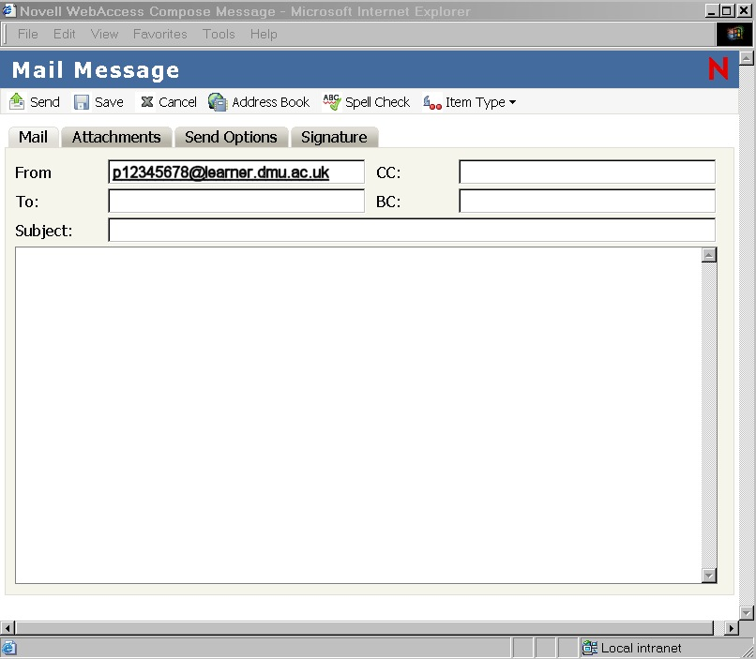

- In the To: box, if it has not been filled in by the computer, type in your own student ID address, for example: P00123456@learner.dmu.ac.uk
- Click in the Subject: box and type “A message from me”.
- Click in the Message area and type “I must change my password in the self service system”.
- Send your message by clicking on Send . A copy will appear in your sent mailbox.
- After a few minutes, the message will appear in your mailbox folder and unopened items folder. It will have dark text and a closed envelope icon . Click on the envelope icon or the subject to open and read the message. When you have opened it the message will disappear from the unopened items folder and the text in mailbox folder will be a lighter shade.
- Logout when you are ready.

What Is My Email Address
Your email address is your pnumber followed by the University email address. For example if your pnumber is p00112233 then your email address is: p00112233@learner.dmu.ac.uk.

