
DMU Website Staff Profile Proforma and Process for Contensis
Introduction – prefix copy loaded onto the Contensis system
The production of staff profiles for the DMU website has been identified as a priority to enhance our:
- Academic reputation - by showing the skills and experience in teaching
- Research reputation - by showing the diversity and success in research
- General profile – by presenting the diversity of expertise available for media comment, advice enquiries from key stakeholders

The De Montfort University website is a key communication tool for all external stakeholders and it is essential that we work together to keep the website updated, the individual academic profile pages are an essential component for the website.

Once your profile is completed and signed off, it will be:
- Held on a central confidential store called Contensis, this is a system that holds all of the website information for dmu.ac.uk and allows web administrators to update details as and when required.
- The concept is that each Academic/Research in the university will be responsible for updating their own profiles on contensis, with the necessary training and support.
- Essential information will be presented on the DMU website as a Staff Profile under the Faculty/School/Department/Research Group/Study that you are contracted to.
- Additional information will be determined by the sections you complete on the form i.e. if you complete the research section then you will be linked to the relevant research group. If you complete the media profile information then you will be linked to an Experts Media Guide.

Initial set up of your Academic profile on contensis
- It is up to the individual researcher/academic how much/little you have your web profile, however there will be a requirement to keep it up to date and all the MANDATORY fields must be completed and is compulsory, all detailed in the appendix section of this document.
- In the first instance your profile should be created on this written proforma, it will then be checked and uploaded by a central team.
- If you have completed a research record form, please use it to cross reference and paste the information, as the fields are similar.
- A photograph of yourself will need to attached (please see notes on photo’s/images) below, alternatively the faculty will organise a photo shoot.
- Please submit your completed form to XXX in your faculty.
- Your information will be checked and a *photograph of yourself will need to attached (please see notes on photo’s/images. Profile photo’s can be taken on request to Faculty Web Officer, this should comprise of a passport size photograph, digital copy only on a one colour background.
- A website link will be sent to you (your profile will be loaded onto a preview server) please check it and send any amends back to the initial sender.
- It will take x working weeks to check, upload and link your profile on to the website from the submission deadline.
- Your profile will then appear on the new contensis website and you will then be issued details on how to manage your individual profile yourself.

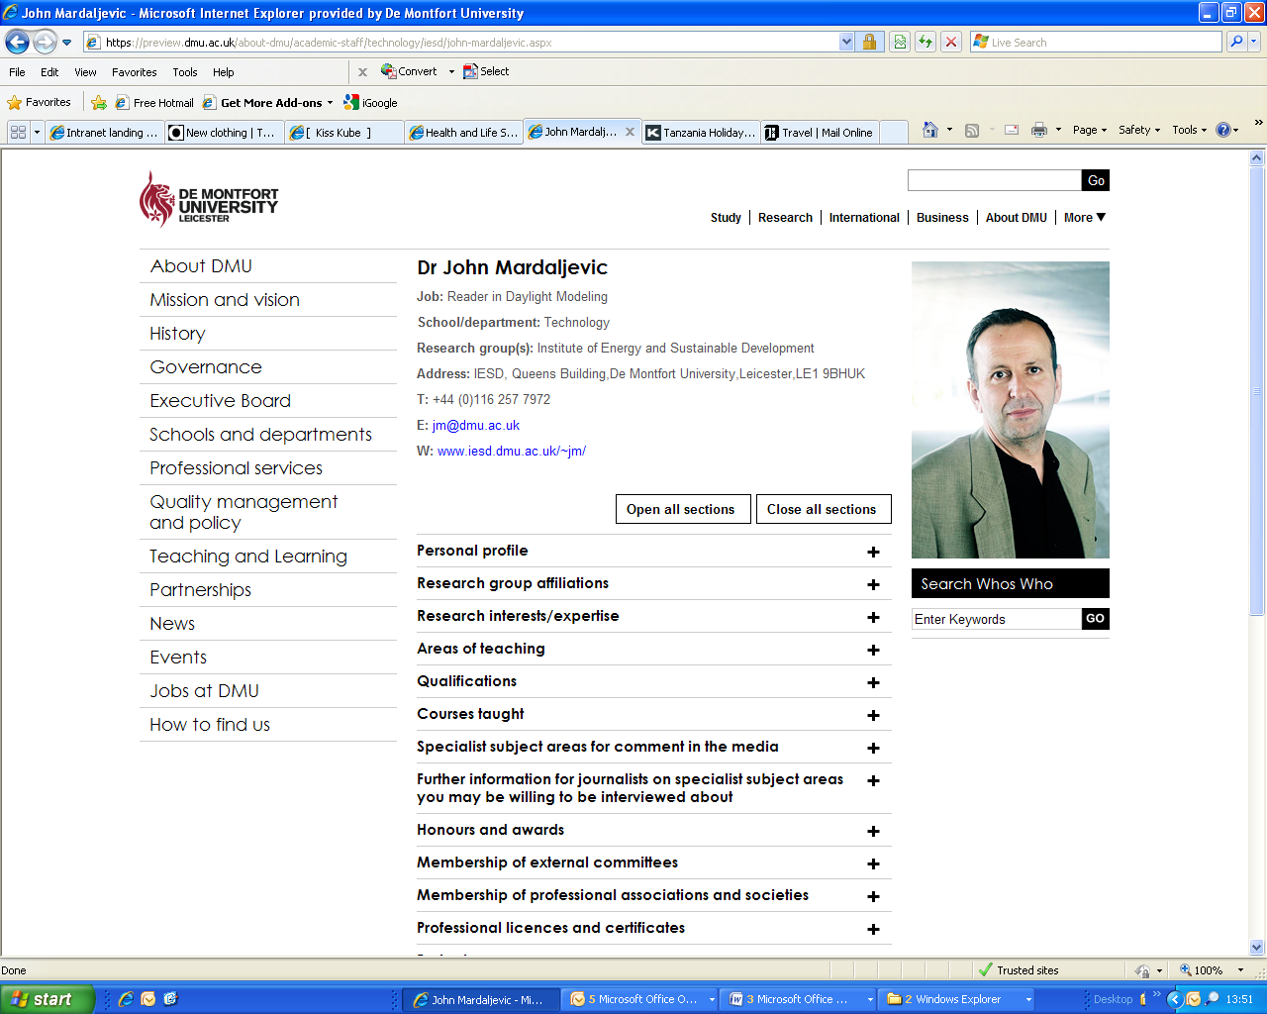

In the future…managing your profile on contensis
- Please endeavour to attend the arranged training sessions on how to administer ‘your profile on contensis’
- Should you require any further assistance please contact your Faculty Web Officer, or Ketna Mistry Adam
- You will be issued a website URL that links to contensis, with a user name and password.
- The profile should be updated every six months at minimum, should you wish to refresh the information more frequently you are welcome to do so.
- All the relevant fields are listed but may not be appropriate for your specialist areas– so only complete the applicable fields.
- Should you require any assistance please contact your Faculty Marketing Manager or Faculty Web Officer.

Notes
To ease duplication of efforts, please note that the requested fields on this form are similar to that of the Research Record Forms. If you have recently completed a research record form then please fill in the relevant fields and copy and paste the others.

Corporate Communications - The Experts Guide
The Experts Guide is a source of academic staff who are able to provide comment to the media regarding their areas of expertise. This can range from a written comment to being interviewed for a televised news piece. From the information you submit an online experts guide will be created and be located on the DMU website for journalists etc. Full media training is available for experts.

Please list which areas of expertise would you like to be a publicised expert in? (Please note that while you may be an expert in many areas, we understand that you may not wish to make yourself available to comment on everything). Please list here:

Further information for journalists on specialist subject areas you may be willing to be interviewed about:

Key Words for Search Engine Optimisation – Enhancing Your Web Profile, Increasing Hits and Traffic for your Web Profile
Keywords and phrases strategically placed and crafted into your website profile page can significantly boost your ratings in search engine results.

If you can select just a few key words that reflect or describe your work or area of expertise and endeavour to repeat (in a subtle manner) those words through your profile page, well placed key phrases will bring more traffic to your profile page.
ALT TAGs explained: three/four words that should appear when someone hovers over your picture on your page, specifically for people with disabilities and voice computers, including any other images that feature on your profile.

PHOTOGRAPH (please mark with a ‘x’ as appropriate)
I will supply a photograph of myself
^{X}
I would like to request a Web Officer to take my photo
- Profile photo’s can be taken on request to Faculty Web Officer, this should comprise of a passport size photograph, digital copy only on a one colour background.
- If you are supplying your own photo please ensure that it is at least 72dpi and has a minimum width of 200pixels and in a .jpeg format. Any poor quality images will be not be suitable for the DMU web pages.
*A photograph of you will enhance and personalise your profile. Not only will it make you recognisable for staff, students and visitors but will add to dimension to your page and the DMU website.

IMAGES
- All images of book covers must be a minimum of 72 dpi and a minimum of 200 pixels wide and in .jpeg format. Do NOT insert images into this document. Please send as email attachment or provide a CD/DVD to your Web Officer.
- It will be assumed that by sending an image, you have permission to use the image/s on the DMU website. You will be responsible for any copyright issues that may arise from the publication on the DMU website.
- Book covers/images ALT tag (Please list titles of the images and associated ALT tag text):

Linking your profile
Please indicate where your profile should be linked (provide a URL):
Research group(s)/institute name:
Courses of study:
Blogs:
Pod casts:
Images:
Other (please detail):

Date:

ESSENTIAL INFORMATION
Title:
Family/Surname/Last Name:
First Names:
Current Job title:
Faculty/Institute/Department/School:
Research Groups/Area:

Contact Details
Telephone:
Email:
External website URL:

Personal profile:
(list or provide an overview containing as many key words about your work/area as possible):

Research group affiliations:

Research interests (list):
And/or Research expertise (list or provide an overview containing as key words about your work/area):

Areas of teaching (list):

Qualifications:

Courses taught:

Honours and awards:
Name of honour / award, month conferred, year conferred, reason conferred

Membership of external committees:
Name of committee, period, function, description, current Y/N

Membership of professional associations and societies:
Association Name, period start, period end, description

Professional licences and certificates:
Licence obtained, certifying institute, not commercially sensitive information

Forthcoming events:
Conferences/festivals/campaigns

Conference attendance:
Title, dates, location, title of contribution, authors, type of contribution

‘Recent research outputs, e.g. selected publications’ produced since January 2008:
- Alan Cope (DORA) to carry out an advanced search with DORA to produce an outputs list for the faculty web officer
- The top10 feeds will appear within contensis (on your personal profile) with the following information showing:
  - Author
  - Title
  - Clickable link to the output in DORA
- The RSS link to also appear in Contensis so people can access the full list – to link back to the list within DORA
- The RSS feed will automatically update as new items are added to DORA or the Academic can re cut and paste a RSS feed if they wish to change the search criteria

Key research outputs:
Any specific highlights

Consultancy/external income generation information:
Area of expertise, previous consultancies undertaken, currently available Y/N, companies worked with.

Current research student supervisions:
Names of research students currently supervised, Mode, supervisory role (1st supervisor / 2nd supervisor) (Extract from EIP report ‘Supervisors and their Students’ could be used)

Externally funded research grants information:
Project title, funding agency, type of project, start date, end date, role in project, collaborators

Internally funded research project information:
Project title, funding source, type of project, Start date, end date, role in project, collaborators

Patents:
Number title and granting body

Professional esteem indicators:
Editorial boards/reviewing activities: journal, date from, date to, role

Impact case studies
Examples of evidence of the ‘Impact’ of research e.g. references to reviews/articles in main stream media, examples of feedback from users, exhibition attendance figures

