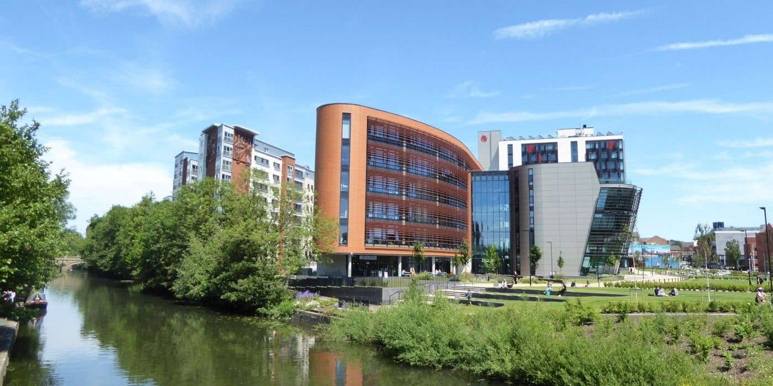

Sustainability Targets
De Montfort University
De Montfort University Published June 2021 Last Updated June 2022
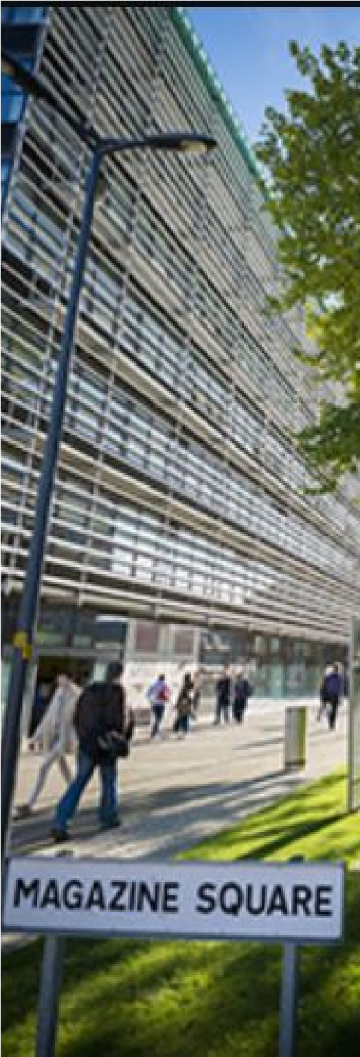
Sustainable Procurement
About Sustainable Procurement
Procurement is a professional specialism covering a range of activity, from advertising new contract opportunities; managing tender competitions with suppliers; ensuring commercial contracts are in place, and helping ensure positive contract management activity takes places during a contract’s term. Although procurement is vital to the University’s operations, it is also the biggest contributor to the University’s carbon footprint and therefore a priority area for embedding sustainability. Sustainable procurement also provides an opportunity to embed sustainability measures into contracts and specifications and to encourage the University’s supplies to adopt more sustainable practices.
Baseline Impact
2005 - Emissions from all scope 3 sources (tCO₂e) - 43,832
2005 – Emissions from procurement (supply chain) (tCO₂e) – 19,990

SMART Targets
2021 – Reduce scope 3 emissions by 14% based on 2005 level
2025 – Achieve a minimum score of 3 (out of 4) in all 8 Procurement and Supplier Engagement elements of the Sustainability Leadership Scorecard
2045 – Achieve net zero carbon from all emissions including procurement
Water

Management

About Water Management

It is written in our Environmental Policy that we will strive to reduce our use of
natural resources such as energy and water and reuse resources whenever
possible to improve environmental performance and reduce the university’s
carbon footprint.
Baseline Impact

2012-2014
– 3 year average of
3
74
,153m

SM
ART Targets

Three per cent reduction in water consumption against the three-year average
from 2012 to 2014 (The three-year average is 74,153m
3

so reduction is 2,224m3)
2020-2021
– 60,806m
3

2021-2022
– 58,582m
3

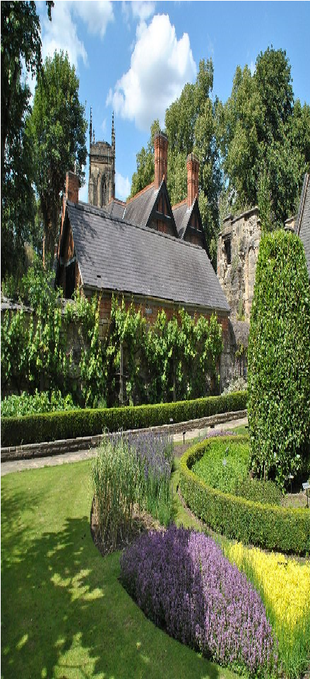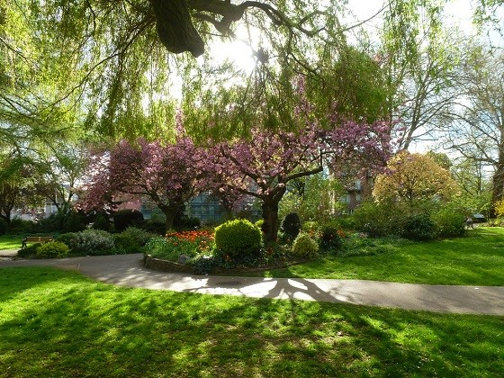
Biodiversity

About Biodiversity

We commit to incorporate actions to support biodiversity within our estate
management practices and to create new wildlife habitats on campus where
possible (in conjunction with the DMU Environmental Policy) and in line with
local and regional action plans. The importance the university places on
biodiversity is reflected the DMU Biodiversity Policy, which can be accessed
her
e
.

Baseline Impact

2012
–
Ecological survey of the campus completed

2016
–
Phase II Habitat Survey completed of the campus

In order to understand the current biodiversity levels on campus, habitat
surveys are completed on a regular basis. The surveys provide the University
with a baseline from which to measure progress on sustainability.
The University’s aims to increase biodiversity on campus through a range of
different measures including management of the grounds and supporting staff
and students to develop their own projects through Green Impact and the
sustainability SEED grants.
SMART Targets

2021/22
– create at least one new habitat on campus
2022/23
– create at least one new habitat on campus

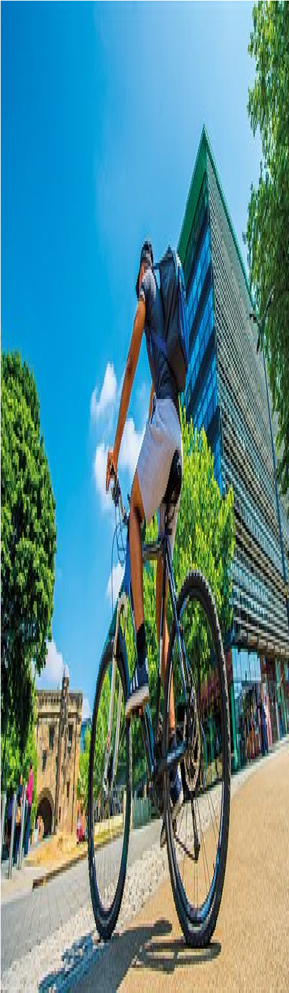

Travel and Transport

About Travel and Transport

De Montfort University (DMU) is committed to the principles of sustainable
development and protecting the environment, above and beyond our legal
obligations. In order to accomplish this, we need to manage our transport needs
to minimise harmful emissions.
Base
line Impact

2005
– Student commuting carbon emissions 8616 tCO₂e

2005
– staff commuting carbon emissions 2,089 tCO₂e

2005
– staff 60% single occupancy vehicle journeys

SMART Targets
2025 - Total carbon emissions from commuting to be a three-year average of <2500
tCO₂e by the end of 2025.

2025 - The percentage of staff commuting by sustainable alternatives to be a three-
year average of 65% by the end of 2023 and 67% by the end of 2025.
2025 - Three-year average for staff commuting by single occupancy vehicle to be 33%
by the end of 2025.

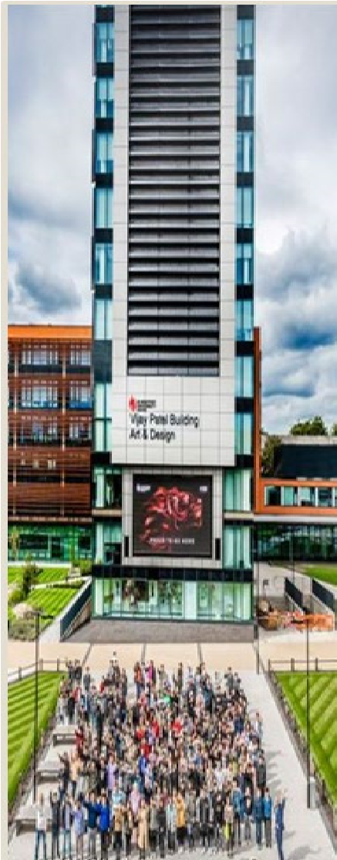
Community Involvement
About Community Involvement
The University is committed to the public good and understands that in order to create a truly sustainable campus staff and students must be engaged in the sustainability agenda and be given the skills and knowledge to contribute. To ensure that this happens the university is committed to developing initiatives and projects which engage both students and staff on this important issue.
Baseline Impact
2018/2019 – Community projects delivered.

Smart Targets
Deliver at least one environmental behaviour change project per year for students (2022/23)
Deliver at least one environmental behaviour change project per year for staff (2022/23)

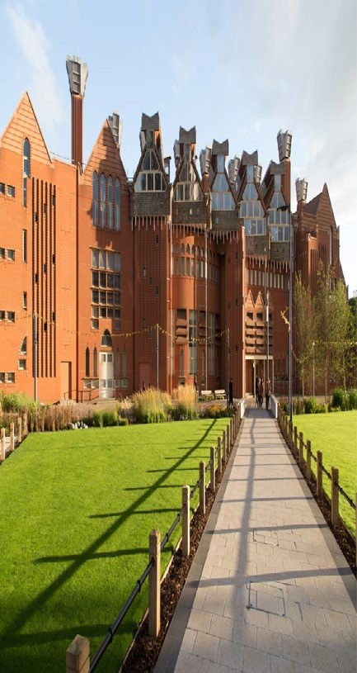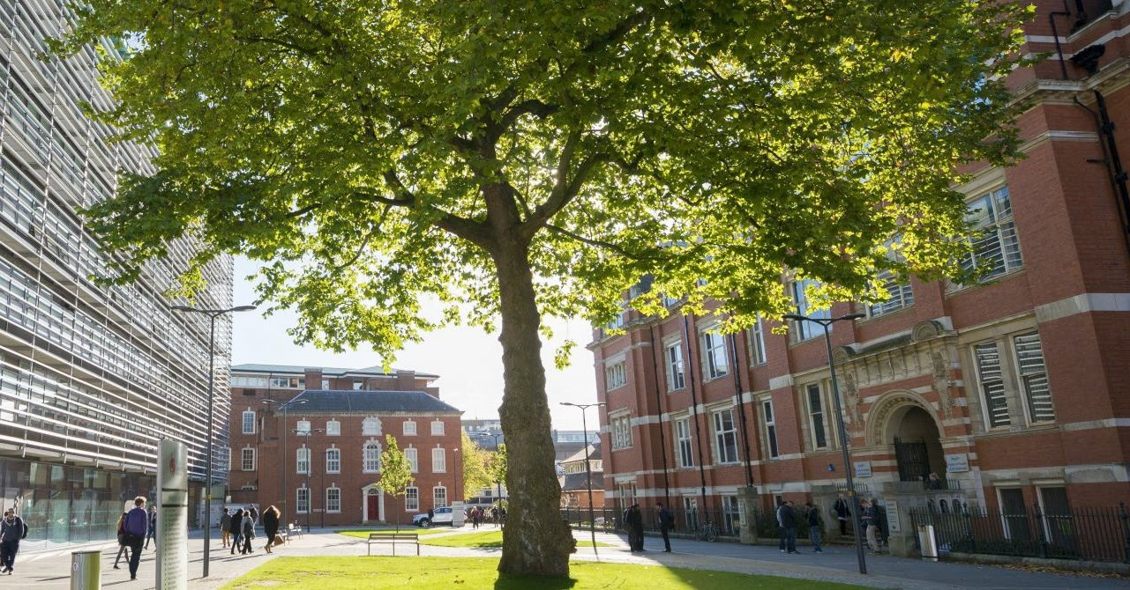
Waste

Management

About Waste Management

Recycling and reducing waste has a number of benefits not only to the
environment but also the university as well. There is a growing pressure to find
new ways of disposing of our waste as our landfill sites begin to fill up and the
costs of disposing of waste increases. Ensuring that our waste is recycled can
reduce the demand for natural resources to create new products, save energy
with lower energy demands for recycled products and reduce greenhouse
gases.

Baseline Impact

2015/2016
– recycle
75
%
of non-residential waste.
The university collects and recycles a wide variety of waste materials from
campus. Data is provided by the waste contractors on the weights of waste
collected and how this waste is disposed of or recycled. This data forms the
basis of calculations to determine the overall recycling rate of waste and the
carbon emissions associated with the different disposal or recycling routes for
the waste.
SMART Targets

2021/2022
- Recycling 93% of non-residential waste
2022/2023
- Recycling 94% of non-residential waste

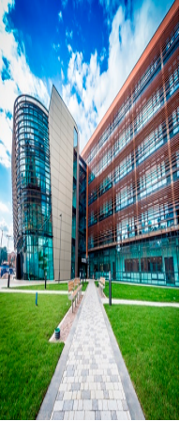
Construction and Refurbishment

About Construction and Refurbishment
Sustainable construction at DMU is guided by the university’s energy policy, which includes the use of various assessment protocols depending on the building size and budget. The allocation of the assessment protocol will be at the discretion of the Director of Estates.

Baseline Impact
Sustainable construction is key to the university approach to new builds and refurbishments. Recent projects such as Hugh Aston and Vijay Patel have achieved BREEAM Excellent certification.

SMART Targets
A sustainable construction assessment will be completed for new builds and refurbishment at the discretion of Director of Estates and Facilities.

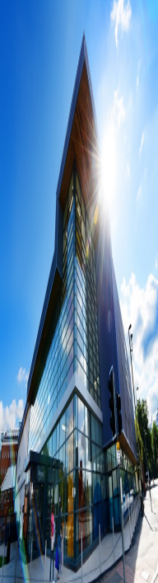
Emissions and Discharges

About Emissions and Discharges
Work to reduce the University’s environmental impacts is now co-ordinated through an Environmental Management System (EMS) which ensures that the university addresses its significant environmental impacts whilst at the same time meeting the requirements of environmental legislation especially on emissions and discharges. The implementation of the EMS has identified the relevant environmental legislation affecting the university and ensured that we meet these requirements.

Baseline Impact
The university ensures it meets it legal compliance obligations through its environmental management system (EMS) which is externally assessed once a year. The EMS meets the British Standard BS8555 for environmental management systems.

SMART Targets
Produce and maintain campus drainage plan to minimise risk of pollution.
Leisure Centre discharge from swimming pool filter backwash to be below 20m3 per 24hrs

