International Workshop on Impedance Spectroscopy
Chemnitz
Proposed Draft of Title and Abstract

Professor Geoff Smith
Leicester School of Pharmacy, De Montfort University, Leicester, LE1 9BH, UK

Through Vial Impedance Spectroscopy (TVIS)
A New Method for the Development of Manufacturing Processes for Injectable Drug Products
Geoff Smith
Leicester School of Pharmacy, De Montfort University, Leicester, LE1 9BH, UK
Through vial impedance spectroscopy (TVIS) provides a new process analytical technology for monitoring the lyophilization process, which exploits the changes in the bulk electrical properties that occur on freezing and subsequent drying of a drug solution, in a non-product invasive way. In this method the electrodes are attached to the outside of the glass vial which is used to contain the product (Fig. 1 LEFT). A typical capacitance spectrum of the vial containing 2 ml of water is shown in Fig. 1 RIGHT.
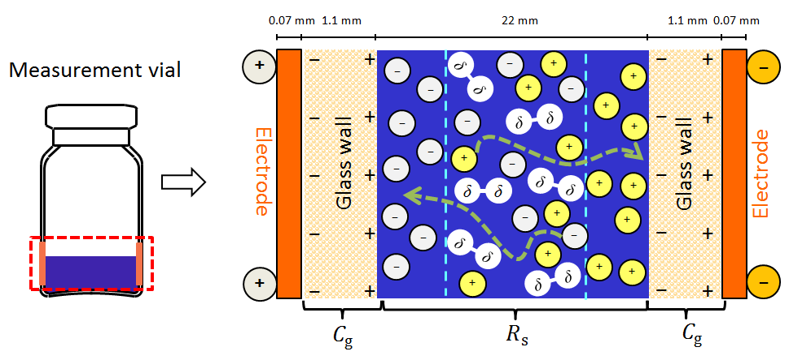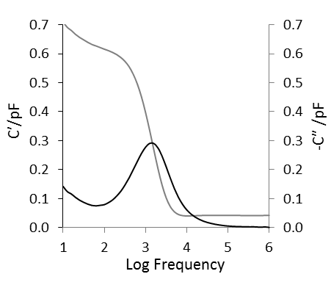
Fig. 1
LEFT Sketch of the glass vial with electrodes (light grey) attached to the outside
MIDDLE: Schematic of the dispositions and movements of charges following the application of the external field.
RIGHT: Typical spectrum of the composite object, the glass TVIS vial containing 2 ml water which is frozen to ~ −30 °C

The peak in the imaginary capacitance (i.e. the dielectric loss) and the step in the real part capacitance (the dielectric storage) are due to a Maxwell-Wagner (Interfacial polarization) process, which originates from the fact that the object under test is a composite of a relatively conductive material, i.e. the cylinder of liquid or frozen solution within the vial, or in the case of pure water it is the cylinder of pure ice, which is in intimate contact with the poorly conductive material, i.e. the glass wall of the container (Fig. 1 MIDDLE).
The characteristic frequency and amplitude of the dielectric loss peak, which is observed in the frequency range between 10 Hz and 1 MHz, is used to follow both the temperature and phase changes that occur on freezing, and the changes in ice content that occur on primary drying in one relatively straight forward method. Opportunities to measure drying rates in the freeze-dryer and ice temperatures within single vials which contain the drug product, and multiple (clusters) of vials, will be described along with recent research into the application of this technique for the determination of key process parameters, such as heat transfer coefficient.

Podium presentation at
The International Workshop on Impedance Spectroscopy, Chemnitz, Germany, September 27th 2017

