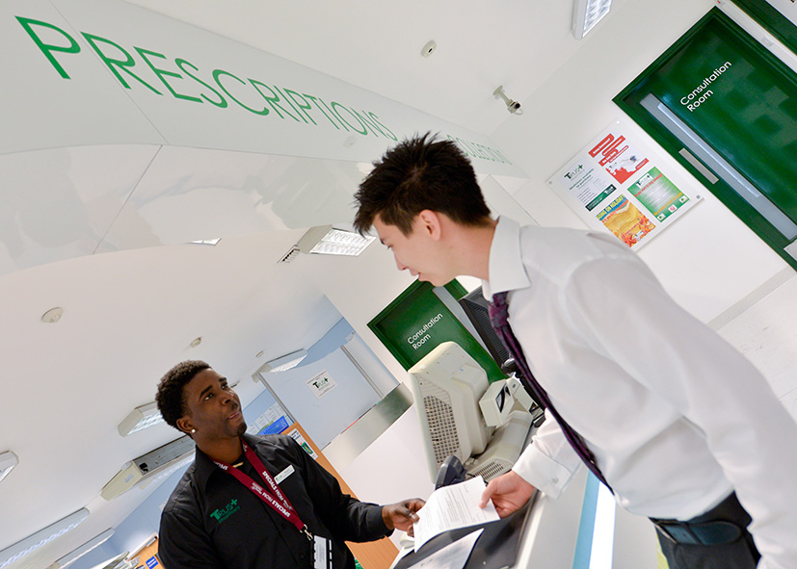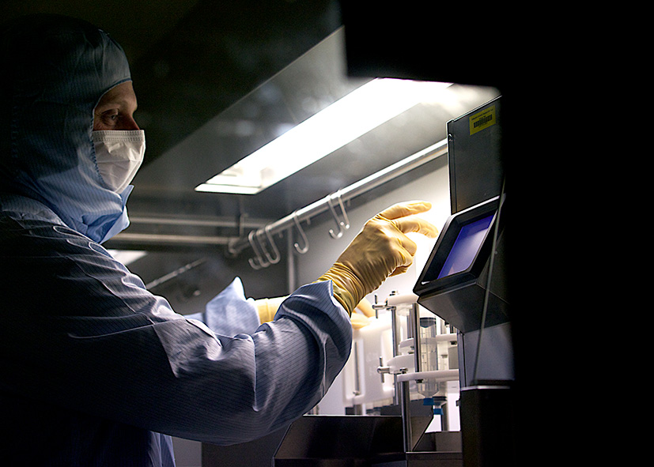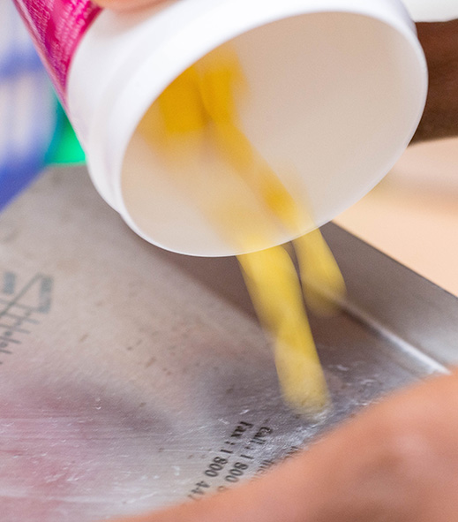

**Pre-Reg Pharmacists**

You will be one of 9 pre-reg’s within the pharmacy department. During the year you will complete rotations within all of the main areas within the department. Throughout the year you will be supported to pass the validations and competencies which will enable you to hopefully work independently as a pharmacist towards the end of the year.

**Rotations**

These are the main rotations included within the pre-reg programme:

* Medicines Information
* Sterile Production Unit
* Non-Sterile Production Unit
* Psychiatric medicine
* Admissions
* Outpatients
* Paediatrics
* Clinical
* Self-directed weeks

Whilst in each of these rotations you will be supported by the experienced leads within the area.

**Induction Period**

During this period you will be trained in the way of working within hospital pharmacy at NUH, so that all pre-reg’s are up to the same standard regardless of prior experience.

**Dispensaries**

Each campus has satellite dispensaries local to clinical areas with the focus on one-stop and near-patient dispensing. At NUH they are technician-led which allows the pharmacists to spend more time in clinical areas. As a pre-reg you will be expected to help support the dispensaries which will help develop your technical skills.

**Medicines Information**

Our largeMedicines Information department is based at QMC campus. You will receive training in all aspects of the medicines information service with an emphasis on making the most of electronic resources. Your training will develop your clinical knowledge, literature searching and problem-solving skills.

**Production Services**

Our large department has a licensed production unit at QMC campus, which manufactures a wide range of sterile and non-sterile products (including TPN, cytotoxic preparations and ‘specials’). There is also a Cytolab at the City hospital campus providing a chemotherapy service to the oncology and haematology units. You will have the opportunity to experience all of these areas.

**What you will do**

**About us**

**Nottingham University Hospitals NHS Trust (NUH) is one of the largest and busiest acute hospitals in England, employing 11,386 staff. We provide care to over 2.5million residents of Nottingham and its surrounding communities and specialist services to a further 3-4million people from neighbouring counties.**

The pharmacy department provides a service to the two main sites within the Trust:

* Queen’s Medical Centre (QMC) – our emergency care site, where our Emergency Department (A&E) Major Trauma Centre and Nottingham Children’s Hospital are located
* Nottingham City Hospital (NCH) – where our cancer centre, Trent Cardiac centre and Stroke Services are based, and where we focus on planned care and the care of patients with long-term conditions

We have national and international reputations for specialist services such as stroke, renal, spinal, breast, neurosciences, cancer services and trauma.

The Trust has an annual income of £874million and approx 2,000 beds (87 wards).

We are at the forefront of many research programmes and new surgical procedures. Nottingham has Biomedical Research Units in Hearing and Digestive Diseases.

Pre-Registration Pharmacist

**Outpatients**

Trust Pharmacy is a wholly-owned subsidiary of Nottingham University Hospitals NHS Trust, established to provide exceptional, accessible and innovative healthcare for its patients, staff and local community. This is where you will gain community experience. There may also be an opportunity to spend time in a “high-street pharmacy” if requested.

**Psychiatric Medicine**

Two weeks will be spent with Nottinghamshire Healthcare Trust who deliver the psychiatric care to the region. This rotation will allow you see a different side to pharmacy and the issues surrounding patients care in this area of medicine.

**Admissions**

Two weeks will be spent on the admission wards at QMC where you will be able to develop several key skills due to the high turnover of patients and the variety of conditions encountered.

**Paediatrics**

Several weeks will be spent within the specialist paediatric wards at QMC, which will give you an understanding of this specialised area of pharmaceutical care.

**Regional Training**

You will be enrolled at DeMontford University as an East Midlands NHS Pre-Reg Student. This is where the regional programme is delivered which looks at key topic areas which are best delivered centrally. At NUH we also run monthly tutorial sessions in which clinical areas are covered by experts in those areas.

**Self-Directed Weeks**

At specific points through the year we allow the pre-reg’s to choose which areas they would like to gain an experience of. Examples include shadowing an ambulance crew and participating in medical undergraduate training.

**Further information**

**Mike Hey**

Pre-Registration Training Facilitator, Education & Training

Queen’s Medical Centre Campus

Nottingham University Hospitals

0115 9249924 ext 64425 or pager 780-8884

[michael.hey@nuh.nhs.uk](mailto:michael.hey@nuh.nhs.uk)

**FAQs**

**What support will I be given?**

The pre-reg facilitator for the trust will line manage you and help guide you through the year. You will also have your own personal pre-reg tutor to help support you. A mentor that is an ex pre-reg at NUH is assigned to all pre-reg’s for guidance should it be required.

**Is accommodation available?**

Accommodation is available off site in modern purpose built flats with a choice of facilities, run by the Derwent Housing Association. There is also an abundance of rental accommodation near to both of the sites.

**Are there opportunities to stay on after the pre-reg programme finishes?**

Yes, we like to retain our junior pharmacists where possible onto the Band 6 Programme

**How much will I be paid?**

The current band 5 pre-reg pharmacist salary (April 2016) starts at £21,909 per year. Additional payments are made for working weekends and bank holidays

**How do I apply?**

All pre-reg hospital positions are recruited through the ORIEL system https://www.oriel.nhs.uk/Web/

**Social life?**

Working as part of a large pharmacy team at NUH is an enjoyable experience. There is always something going on and many different social events happening throughout the year.

Information about ‘what’s on’ in Nottingham can be found here:

<http://goss.nottinghamcity.gov.uk/index.aspx?articleid=24550>

[www.nottinghamshire.gov.uk/whats-on](http://www.nottinghamshire.gov.uk/whats-on)