Role Model Guidance
Role models are vitally important as we work towards a more inclusive university, that is diverse at all levels of the organisation. They help break down myths and demonstrate that personal identities are not a barrier to progression while also providing visibility and a sense of belonging for those that share characteristics.
Role models help to:
- Challenge stereotypes and misconceptions about roles and the people that can fulfil those roles
- Break down barriers and perceptions, and bring about institutional change
- Make the diversity of the university more visible and real,
- Foster a sense of inclusion and an open culture and reduce feelings of isolation
People perform better when they can see other people like them in similar roles they aspire to. Role models help to show others from underrepresented groups that they can be their genuine selves, and achieve what they want to. Role models can also really help others feel more comfortable about being out about their characteristics (e.g. LGBT, hidden disabilities) if they can see others accepted for who they are. We know that this is really important for both career and personal wellbeing.
Everybody can be a role model – no matter the size of your contribution, or your role and function at the university. Every role model we have contributes to a more inclusive and open university.
Here are some ideas to get started:
Create a profile
Creating a profile for our website is a great way to be a role model – we will use these profiles on our intranet site and at key points during the year aligned to EDI celebration or awareness dates to inspire to our staff base (and student where appropriate and agreed with yourself). You may like to write a profile (preferably with a picture), or even record a video!
Here’s some ideas as to what you may like to write or talk about:
- Your story! Who you are, what background you’re from, how you grew up and how this led to where you are today in the position you’re in at DMU
- Any barriers you may have overcome
- What it has taken for you to be successful
- Cultures you have encountered along your journey
- How you’ve helped foster a culture of inclusion
- How you’ve helped to ‘reverse mentor’ allies
Below you will find some sample profiles, which we hope will inspire you to create your own! Please contact equality@dmu.ac.uk if you’re interested in writing or recording a role model profile and we can assist.
Be active
Being an active role model is additionally a great way to promote inclusion, and help others. You could do this by, for example:
- Championing equality, diversity and inclusion in meetings – reviewing documents and processes for fairness and inclusion.
- ‘Sponsor’ others from underrepresented groups in meetings and to colleagues – speak about the great work they’re doing.
- Take an active role in promoting EDI at DMU, for example, promoting Decolonising DMU, joining groups such as the DMUPride planning group, leading on, contributing to or attending events.
- Speak about your experiences and your journey with others.
- Provide support to others – this could be through the mentoring or coaching service, or simply being available to meet for a coffee (you may wish to add this to your profile).
- ‘Reverse mentor’ colleagues – mentor more senior staff who don’t share your characteristics.
- Join a staff network – please visit here for further information.
- Utilise the ‘allies guide’ to understand more about how you can support others.
- Actively call out poor behaviour, comments or messages when it is safe to do so – for further information, advice and guidance on this please visit the allies guide.
Sample role model profiles:
Diya Rattanpal (former DSU Student Executive Officer for Equality, Diversity and Inclusion) and Amber’s Story: please click here to access the video
Sarah Thomson – Director of Social Impact and Engagement
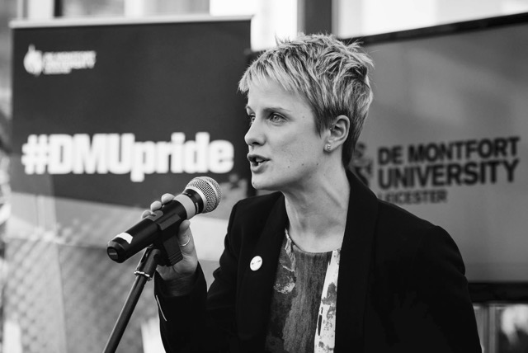
I came out at school when I was studying for my A levels so I was never really in the closet it wasn't until I got to university that I realised this wasn't the case for everyone. When I was studying for my undergraduate degree I became very involved with the LGBT group at the university. I spent a lot of time with students who were just coming to realise that they were LGBT and often university is the first time people tell someone about their sexuality. For most people this was a positive experience but I remember some students who found it very difficult.
University at the turn of this century was the era for being involved in LGBT politics, in my opinion. During my time at university I saw the beginning of the movement to repeal Section 28, to lower the age of consent to 16, to give adoption rights to gay couples and to see legislation that would give civil partnerships to LGBT people – it seemed like we marched every weekend and shouted from the rooftops that we wanted to be treated equally.
16 years on and I now work at a university and I see students on that same journey, understanding who they are and what their fit is in the world. University is a wonderful place to test out who you want to be and sexuality is just one part of that. I had a friend at university who came out and he said to me 'I think my mum will be more upset to learn that I now read the Guardian than the fact I am gay'. Being who you are is so important to living an authentic life but it will also make you better at what you do. People who can truly be themselves will perform better at their jobs, studies and in all of their relationships and that is why it is so important to see positive role models all around you, so that you can feel like you can be yourself, whoever that self is.
Since I have been at DMU I have been proud to have organised #DMUpride – an annual celebration of events and activities that celebrate the LGBT community on our campus and in our city. Events have included LGBT films and plays, guest lectures, conferences, talks and international visitors. This year we took a group of students on a #DMUglobal trip to see Pride in New York City and to work with local communities that support LGBT people.
The most interesting fact that I have found about coming out is that you never stop doing it. New jobs, new friends, new colleagues will always result in you needing to 'come out' I hope to inspire people to be proud to do that and for it not to be something that they fear or are ashamed of. I am proud to work for a university that allows us to be who we are.
​
Dr David Dee - Associate Professor/Reader in Modern History at DMU
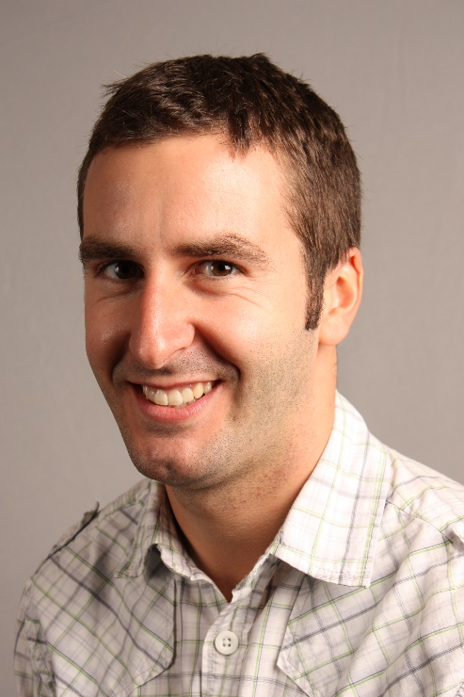
David took Shared Parental Leave (SPL) – introduced in the UK in 2015 - between January and July 2020 after the birth of his daughter Abigail.
‘I’d been aware of Shared Parental Leave for a while when my wife and I found out we were expecting our first child in 2019, and it was something that we were both very keen to look into. There is a huge amount of information out there about SPL, which at some times is quite overwhelming, but I found that DMU’s own guidelines were really clear and easy to follow. I also found DMU’s HR team and my own Line Manager very knowledgeable about the scheme and very helpful. After initially being daunted by the arrangements with both of our employers, my wife and I found things were organised really smoothly’.
David looks back really positively about his time on SPL:
‘Taking Shared Parental Leave was one of the best decisions I have ever made. Being around for the first few months of Abigail’s life and really being able to get stuck into parenthood, all whilst knowing that I had continued support from DMU, was great. I would encourage all prospective parents to look at the SPL scheme as it had huge benefits for our family.’
David is happy to talk about his experiences regarding SPL to anyone who may be interested in the scheme. His email address is ddee@dmu.ac.uk
Dr Hardeep Kaur Basra – Academic Learning and Organisational Development Consultant
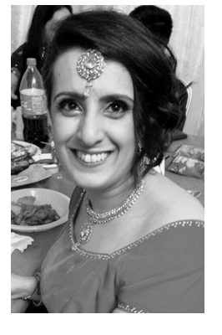
How long have you worked at DMU and what do you do? (Let us know what your role involves not just the title)
I have worked at DMU for over 3 years and I am an Academic Professional Development Consultant. In this role I am the institutional lead for the Advance HE accredited provision, which includes the Postgraduate Certificate in Academic Practice/Academic Professional Apprenticeship (PGCAP/APA) and the HEA Professional Recognition Scheme. I also lead a CAI Expert Group for the Decolonising DMU Project, and I proactively embed and champion the decolonising curricula and pedagogy agenda. I am also a co-chair for the BAME Staff Network.

What does gender equality mean to you?
I would describe myself as an academic activist and as such I work very hard to address all inequalities. As someone who has had the unfortunate experience of encountering gender discrimination, I feel it is very important through education and meaningful action that equality is championed to enable all women to achieve their best and to have the same equality of opportunity.

How can we amplify women’s voices at DMU?
We need to create safe and active platforms for women to share their lived experience so we can learn what works and what does not. This would then empower DMU Women to take further action. We also need more women to mentor and sponsor others, those succeeding should help others to progress and accomplish too.

What is the best advice you have ever been given?
I was once told to “just be the best version of yourself”. From this I learnt being authentic is key. Trying to be something you are not or trying to put a version of yourself forward because you think that is what people want to see is not ideal. Be true to yourself, recognise your strengths and recognise where you can add value.

We encourage all DMU Women to prioritise self-care, do you have any tips you can share?
I have recently taken up running and I find this really good for my mental health. It gives me a chance to destress from work and escape from and an ever busy homelife. Running is me time!

Who inspires you and why?
My mum is my inspiration; widowed in her early 30s with 4 young children she worked tirelessly to ensure we were provided for. She put us all through university and helped ensure we had a prosperous future. Her work ethic is to be admired and her willingness to always put others first has encouraged me to always take the extra step to go above and beyond. And more recently, my daughter (with along with her cousin) has been truly inspirational - she is raising funds for The Little Princesses Trust, who make wigs for children with cancer. They are both donating their hair. https://www.justgiving.com/fundraising/hardeep-basra

What professional achievement are you most proud of and why?
I recently became a Principal Fellow of the Higher Education (PFHEA) for demonstrating strategic leadership in learning and teaching and much of my recognition focused on the work I have done on addressing equality and diversity in learning and teaching. I am only fifth academic to achieve this at DMU and one of handful of women of colour to receive this accolade in the sector. Considering I do not hold a post carrying positional authority or one that has significant seniority getting this achievement is even more special; it recognises my willingness to go above and beyond and my ability to make sustained strategic impact at institutional, national and international level.

What challenges have you had in your career and how did you overcome them?
I started my career as a lecturer in International Relations but was often on fixed term fractional posts. This carried on for nearly 10 years and I never seemed to be able to get that break. Whether this had anything to do with my gender or race it is hard to say but did I feel I was denied opportunities. In the end I transitioned away from being a subject disciplinary academic to one focusing on enhancing learning and teaching practice. Within this type of academic position, I feel I have been able to add greater value and reward as I am shaping and influencing the teaching practice of others to enhance the student learning experience. I think being resilient and taking on constructive feedback has been the cornerstone to my professional development. Recognising weaknesses, taking positive action and turning them into strengths. I think you need to find your voice and create your own opportunities and not rely on others to open the door of opportunity for you.

What does being co-chair of the BAME Staff Network mean to you?
I know in this role by working with others I am making a difference to my fellow BAME colleagues, whether this is through active campaigning for changes in institutional policies and processes, or by supporting career progression through mentoring, workshops or guidance or just by creating opportunities to listen and bring liked minded colleagues together. Also, as a co-chair I have the chance to work collaboratively with the Equality, Diversity & Inclusion (EDI) team and the Deputy PVC EDI to collectively support the wider agenda. Lastly, I have the pleasure to work alongside two experienced co-chairs, Atika Kohli and Sherilyn Pereira, and their insight and steer is invaluable. Together we are a dream team!

